

**Alexandria University**

**Faculty of Computers and Data Science**

**Business Analytics Department**

**Graduation Project**

**2022/2023**

Personalized Occupation Matching System

Authors:

Amir Wagih Elsayed

Basel Mahmoud Badee

Marwa Mahmoud Mohamed

Nourine Amir Ahmed

Omar Arafa Ibrahim

Supervisor

**Dr. Ahmed Almourady**

01/01/2023

# Abstract

Currently, the ICT industry is the sector with the highest growth rate in Egypt. During the fiscal year 2021–2022, it had a growth rate of 16.3%, which was higher than all other economic sectors in the state for the fourth year in a row.[1]

This growth does have a great reflection on the minds and talents of the youthful students starting their careers in the sector, although we find the Egyptian ICT job market is facing several challenges on both sides of the recruitment equation. Companies assign many technical consultants, who report a lack of skilled workers. Individuals who struggle to understand what the job entails and then struggle again to acquire their understanding, hoping that it turns out correctly and is still available in the market after they finish educating themselves about it These challenges are further amplified by how the students view college education in Egypt, where graduating from a high-degree college is considered a social perk in many societies. This college degree may or may not fit the student’s desires for his career path. All these challenges may be linked to the lack of communication between the job market's needs and student qualifications.

The project addresses a highly important issue: the issue of the gap between employment growth and an individual's abilities and skills[2]**.** in the ICT job market in Egypt, triangulating it from three perspectives: the students as the future workforce, the job market as companies and recruiters seek the best candidates, and the skills required to meet the job requirements. This Firstly, by bringing them into a test to explore their interest; secondly, by addressing a strong, well-structured, and scientifically defined connection between the occupations in the Egyptian labor market with a description of the skills and competencies required for each occupation; and finally, by recommending the courses that would help the student acquire each skill.

# 

# Acknowledgment

It has been a great opportunity to gain lots of experience in real-time projects, followed by the knowledge of how to design and analyze real projects. For that, we want to take this opportunity to express our gratitude to our supervisor, Dr. Ahmed Al-Mourady, for bringing the weight of his extensive experience and knowledge and guiding and supporting us through our path in the project. His high standards have made us better at what we do.

We would also like to express our deepest gratitude to our sponsor, DULLENI, for sponsoring our project; their contribution was vital to continuing our work. We would also like to thank Mr. Abdul Malek and Mr. Mohammed Tarek for advising us on the methodology. Their advice was beneficial and greatly appreciated.

Moreover, it is our duty to thank all the members of the discussion committee for their generous discussions and time.

Finally, we wish to acknowledge our faculty of computers and data science under the administration of the Dean Dr / Yasser Fouad

# Tables lists

## Table of contents

**Abstract** **1**

**Acknowledgment** **1**

**Tables lists** **2**

Table of contents 2

**Chapter one: introduction** **4**

Preface 4

Significance and motivation 5

Aims and objectives 6

**Chapter two: literature review** **6**

Introduction 6

The previous studies and work 7

occupational classification 7

1. International Standard Classification of Occupations 7

2. European Skills, Competences, Qualifications and Occupations(european) 8

3. national occupation classification 8

4. standard arab classification of occupations(arab soc) 9

5. Central Agency for Public Mobilization and Statistics 9

Job postings platforms 10

courses 10

Frameworks 11

1. ONET my next move 11

2. QUALICHAIN 11

3. SkillsTx, SFIA (Skills Framework for the Information Age) 12

4. The ACM (align my curriculum framework) 12

**Chapter three: materials and methods** **13**

Methodology 13

What is RAD methodology 13

Reasons for choosing RAD 13

Implementation of RAD 14

Gantt chart 14

Requirement planning 14

The architecture of the framework: 14

Interface 15

Database 16

Middleware 16

Data analysis (HubSpot) 17

Skills Matching 18

Knowledge extraction 20

Data collection and preprocessing component 21

Skills Extraction: 21

classification 21

Requirement Analysis 22

Functional Requirements 22

Nonfunctional Requirements 26

Use Cases & Use Case Narrative 26

Use case 27

Use case narrative 28

Data Flow Diagram 30

Sequence Diagram 33

Entity Relationship Diagram 42

Chapter four: results and discussion 43

Prototype photos 43

Registration Page: 43

Login Page: 44

Home Page: 45

Test Page: 46

Test: 46

Result Page: 47

Jobs Page: 47

conclusions - what we discovered along the process 48

results -the till now reach 49

future work 49

References **49**

**Future work** **53**

List of acronyms and symbols (abbreviations) **53**

### Chapter one: introduction

#### Preface

The ICT sector has been at the forefront of the number and value of acquisition and merger deals in the MENA region during the first half of 2022. According to the Annual Economic Bulletin for FY2020/21[1] and while observing this sector, we find a lot of talented people. More than 50 universities and 100 institutes each year graduate more than 500,000 people [3]. Yet many recruiters do report the lack of available competencies in the market.

This is to assure that university graduates have a high labour force participation rate, but it breaks down into low employment rates, high unemployment, and underutilization rates[4] these to find that An alarmingly large rate of education-occupation mismatch and skill underutilization is reported by university-educated Egyptian youth.

Self-reported dissatisfaction with the job situation was widespread among university graduates, and the majority of them were searching for another job to get higher pay or attain a better working environment[4].

In resolving these issues, The Ministry of Communications and Information Technology has shown great efforts in the field of digital skill development through many platforms, institutions, and initiatives showing the significance of skill definition and skill premium ROI for graduates of ICT programs in Egypt [5].

These amazing efforts are met with challenges, complexities, and, most importantly, extremely high costs In 2021, the number of trainees increased, and the budget for technical training was doubled, from 148,000 trainees with a budget of EGP 400 million in 2020 to a target of 200,000 trainees with a budget of EGP 1.1 billion during FY 2021-2022[6].

This leads us to the term of our problem statement, "skill gap", Different definitions of the skills gap exist. Formal methodology for quantifying a "skills gap," or the difference between the skills required for a job and those possessed by an applicant[7].

**Reason for choosing this topic**

The ICT sector was selected as the primary industry or field in which the project would be implemented for the following reasons:

1. The author's area of interest, study, and domain knowledge
2. Egypt's current high demand in this field [6]
3. The highly dynamic nature of this labor market
4. The availability of a vast quantity of job posting data
5. The rate of introduction of new technological skills to the market

Therefore, the need for this sector's skills to be addressed in a dedicated framework and not integrated into a job posting platform is stated.

**The solution**

Provided is a framework that articulates the problem (triangulating) from three views, allowing the student to discover his interest in the career path through the Holland Code Interest Test, Presented in our project that brings a link between the ICT professions that are actively available in Egypt and the skills needed to apply this occupation and perform the required tasks on an average level, and finally through linking the course recommendations scraped that could help the user acquire a set of skills for an occupation.

#### Significance and motivation

There is a big debate in the literature, as although most universities nowadays are focusing on and providing their students with the necessary employability attributes, the research results reveal that graduates are still not equipped with the needed modern workplace competencies, i.e., the employability gap [8] Skills that were in demand a few years ago are now viewed as outdated because the job market is quickly altering, especially in professions related to technology. As a result, individuals who graduated from technology-focused universities may find it difficult to develop their careers or find a job. Because of this, more and more students are attempting to expand their skill set through academic or online courses. However, keeping up with changes in the labor market is a major difficulty for universities and students. Therefore, it is more crucial than ever for university students to make informed and effective course choices. More precisely, they should steer clear of programs that teach outmoded abilities and favor those that emphasize knowledge that is in high demand now and probably will continue to be so in the future.

Also, given the huge number of graduates who are shifting careers because they didn't find their passion or interest in their colleges and so decide to work in another field, which is time- and economically consuming for them, we should help them find the occupation that matches their interests through an interesting test.

So as we are final-year students in the ICT sector we trying to asset them to know what are skills required in the Egyptian labor market and how to acquire them through courses and curricula recommending what the best match job for their skills is.

#### Aims and objectives

The aim of this project is to develop a framework that leads the students into career guidance for choosing their upcoming profession in the ICT industry, with supportive modules that help the student walk through the different aspects of the profession

The objectives were to use various computer-related techniques to analyze and compare job postings and curricula to help students fill the skills gap and take on more effective courses.

the main objectives

1. Developing a database that contains the classification and job characteristics
2. Discovering the up-to-date skills that are actually needed for each job
3. Offer the students the opportunity to investigate what they are interested in.
4. Provide suggestions for educational opportunities as courses to acquire the desired skill set

the sub-goals

* Assist educators in the process of designing future curricula by providing reports on the information technology market competencies required for each job.

### 

### Chapter two: literature review

#### Introduction

The research that was conducted throughout the project covered a wide range of topics, mainly in four phases for this term. Each phase was developed to answer key questions related to solution development.

The first and foremost concern was looking for previous studies in the same field that either addressed the same problem or had a common objective of the research, The objective of this phase was to establish a basis for knowledge of the problem, its attributes, factors, and results, in addition to addressing the challenges that may arise during the process of solution development.

In order to have a more detailed search approach that results in a highly related and strong review, we tried applying some filters and guidelines as follows:

1. geographical filtration concerning Egypt or the Middle Eastern job markets
2. Competencies and skills evaluation studies in the ICT industry that were specifically targeted

The second concern was to compile a list of authorized and real-world data on the jobs that exist today in the global ICT market in order to begin filtering and customizing it for Egypt. This research began by studying both global and national occupational classifications.

The third phase was to evaluate data from job posting platforms, The objective of this phase was twofold: first, to gain a full capture of the ICT job market data in Egypt, and second, to decide which platform should be used in our project.

The fourth was the search for both global and local competitors for the framework, The objective of this phase was to compare our framework to those already existing and identify gaps or areas for improvement.

#### 

#### 

#### The previous studies and work

##### occupational classification

A categorization of occupations is a method for organizing all employment in an organization, sector, or nation into a clearly defined set of groupings based on the activities and responsibilities of each position. It typically consists of two parts:

The classification system itself, which specifies how occupations are to be classified into the classification's most precise groups and how these detailed groups are to be aggregated into larger groupings

-The descriptive component, which typically includes descriptions of the tasks and responsibilities as well as other aspects of the jobs belonging to each of the defined groups, These descriptions might be considered occupational vocabulary[9].

###### I. International Standard Classification of Occupations

The International Standard Classification of Occupations, abbreviated as ISCO, is an international classification under the responsibility of the international standard classification of occupations (ILO)[10] for organizing jobs into a clearly defined set of groups according to the tasks and duties are undertaken in the job.

The current version, known as ISCO-08, was published in 2008 and is the fourth iteration, following ISCO-58, ISCO-68, and ISCO-88.

Structure

Each group in the classification is designated by a title and code number and is associated with a description that specifies the scope of the group.

* Major Group is denoted by a 1-digit code, example 2 Professionals
* Sub-Major Group is denoted by a 2-digit code, example 22 Health Professionals
* Minor Groups are denoted by 3-digit codes, example 221 Medical doctors
* Unit Groups are denoted by 4-digit codes, example 2211 Generalist Medical Practitioners

###### II. European Skills, Competences, Qualifications and Occupations(European)

ESCO is the European Code of Occupations, which is an extension of the American Code of Occupations (SOC) developed by the DG Employment, Social Affairs and Inclusion of the European Commission in collaboration with stakeholders and the European Centre for the Development of Vocational Training [11]

Structure:

is divided into main 10 major groups

then these groups are divided into sub-majors and continued to be divided till we reach the occupations which are 3008 occupations

###### III. national occupation classification

The NOC has been created and maintained as a result of a partnership between Statistics Canada and Employment and Social Development Canada.[12]

Structure:

is divided into 9 major groups then it is divided into minor occupations 583

* 1. Management occupations
  2. Natural and applied sciences and related occupations
  3. Health occupations
  4. Occupations in education, law and social, community and government services
  5. Occupations in art, culture, recreation, and sport
  6. Sales and service occupations
  7. Trades, transport and equipment operators, and related occupations
  8. Natural resources, agriculture, and related production occupations
  9. Occupations in manufacturing and utilities

###### IV. standard arab classification of occupations(arab soc)Published through the Arab labor organization platform

Is a translation of the ISCO codes into the Arabic language [13]

###### V. Occupational codes in Egypt

The version published on Central Agency for Public Mobilization and Statistics was translated version of the ISCO and had no additional attributes or modifications to fit the Egyptian labor market [14]

The version used by the National Authority for Social Insurance was not related to the hierarchical structure that the occupational codes should follow and didn’t include any descriptions[16]

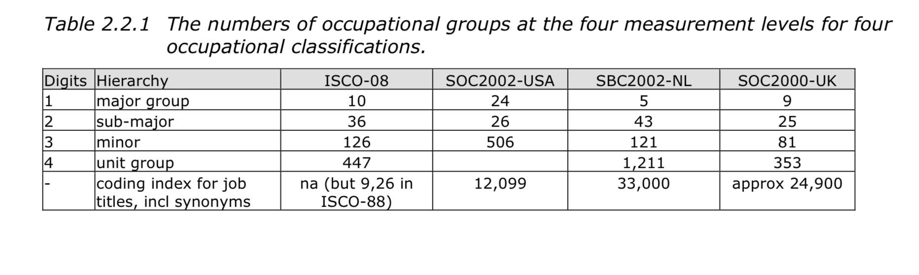Fig 2.1

The SOC has been changed four times: in 1980, 2000, 2010, and again in 2010. The 2018 SOC system is the most recent update. The U.S. Bureau of Labor Statistics called it a "multi-year process." The O*NET 25.1 Database added the O*NET-SOC 2019 Taxonomy in November 2020, which was in line with the 2018 SOC system. It said that "updates and the addition of new and emerging occupations make sure that the O*NET-SOC taxonomy not only represents the SOC structure but also shows how the world of work is changing because of new technologies, innovative business practices, and the new way work is organized."

##### Job posting platforms

Wuzzuf and Naukrigulf [18][19] were chosen for use in our project as they are well-established platforms in the ICT job market in Egypt for the following reasons:

1. Ethically, where those websites allow web scraping and provided their content is used respectfully
2. The update factor of their platforms was also a key factor in our decision to use them, as we needed to ensure that the data we obtained was up-to-date and accurate. job postings are getting updated frequently where:
   1. Wuzzuf: Each week, approximately 917 jobs are posted, including 161 "IT and Software Development" jobs.
   2. Naukrigulf: Approximately 960 jobs are posted each week, including 131 "IT and Software Development" jobs.
3. The number of postings in IT and software development across Wuzzuf and Nukagulf is quite significant, with an average of over 150 postings per week
   1. Wuzzuf: 7487 total job postings in Egypt, 1485 "IT and Software Development "
   2. Nukrigulf: 8183 total job postings in Egypt, 1495 in "IT and Software Development."
4. The geographical factor of where these job postings are available is also worth noting.
   1. Wuzzuf is an Egyptian-based jobs website
   2. Nukarigulf is a Middle Eastern-based jobs website.

##### courses

Bridging the gap between education curricula and job market requirements will be accomplished through three types of education: traditional education, which takes place in universities or other educational institutions; regional rising, such as EFWD; and global giants, such as Coursera or EdX.[20]

The chosen source of the framework chosen for data scrapping was the third one, specifically Coursera, for the following reasons:

##### Frameworks

###### I. ONET my next move

is a website funded by the U.S. Department of Labor that provides information on career options and job search resources. The website is designed to help people explore different careers and find job openings that match their skills and interests. [21].

Upon visiting the website, users are presented with a search bar where they can enter a job title, keyword, or industry to find information about specific careers. The website also offers a number of tools and resources to help users plan their careers, including:

1. A career interest test that helps users identify their skills and interests and suggests career options that may be a good fit for them.
2. Detailed information on more than 900 occupations, including job duties, education and training requirements, and salary data.
3. A job search tool that allows users to search for job openings in their area or by job title and location.
4. Information on education and training programs, including apprenticeships, certificates, and degrees.
5. Tips and resources for writing resumes and cover letters, preparing for job interviews, and negotiating salaries

###### II. QUALICHAIN

is a project funded by the European Union's Horizon 2020 research and innovation program, whose goal is to delocalize education. Its primary targets are four areas: lifelong learning, university process optimization, staffing the public sector, and providing recruitment and competency management services. Our interest in this project was mainly because of their methodology for getting the job market data and how the project is able to extract the relevant knowledge from their targeted job market by analyzing job posts. This process is displayed in full detail in their deliverables, which helped us determine the structure and architecture of our project going forward.[22]

###### III. SkillsTx, SFIA (Skills Framework for the Information Age)

SFIA was formally launched in 2000[,](https://sfia-online.org/en) comprising 7 levels of responsibility and 102 professional skills or competencies.[23]. The Kingdom of Saudi Arabia has adopted the SFIA Framework as its digital skills framework under a country-wide license. SFIA Mapping to Saudi Classification of Professions [24]

1. The targeted audience consists of ICT professionals and hiring managers.
2. For cases involving students, the interface is challenging to use.
3. The architecture is complicated for the students to understand and recognize as they process the simple structure of the job openings they find on online platforms.

SkillsTx includes a pre-recommendation test (leaves the choice to the user to determine which level of expertise he is at to start this test). Each test consists of a group of different surveys, and each survey consists of a group of different questions.

For a student (386 total questions) and even a professional adult (468 total questions), the total number of questions in each test is relatively large and time-consuming, with an average completion time of 2.5 consecutive hours of the user answering questions[25].

the surveys of each test are divided into 9 areas of interest Survey Focus

1. short survey to check your readiness,
2. Personal Profile/Levels of Responsibility (A survey to determine your Generic Attributes)
3. Personal Profile/Levels of Responsibility (A survey to define your personal profile)
4. Strategy and architecture
5. Change and transformation
6. Development and implementation
7. Delivery and operation
8. People and skills
9. Relationships and engagement

the framework also limits the user to a given time inside the framework to answer the surveys of (10 days) starting from the user's registry timing

###### IV. The ACM (align my curriculum framework)

-The output of the framework was a matching algorithmic using single labeling for both the job postings and curricula data which had an ended result of a simple word cloud concerning each sector in the ICT field according to their classification

The intended or targeted users of the ACM framework were the stakeholders in the industry and the curriculum developers.

The geographical scope of implementing this framework includes Saudi Arabia.

### 

### Chapter three: materials and methods

#### Methodology

##### What is RAD methodology

The Rapid Application Development (RAD) methodology is a versatile strategy for rapidly developing and deploying software applications. The RAD approach was successfully created to adapt to changes and new inputs like features and functionalities, upgrades, etc. At every stage of the development process, it is designed to be adaptable to alterations, such as new features and functions. [26]

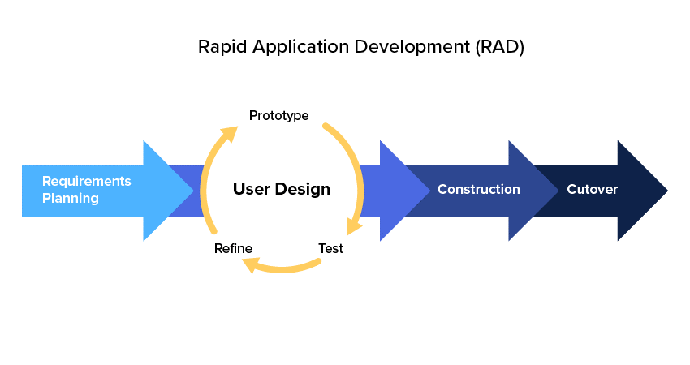

Fig 3.1

##### Reasons for choosing RAD

The versatility and adaptability of the RAD methodology allowed us to create a prototype in a short period of time to test our requirements and make sure we were progressing as needed with the user's input as a guide. Also, the need for fast validation of the idea required us to create a quick interface to get insights, using these insights as the coal for the next prototype.

##### Implementation of RAD

###### Gantt chart

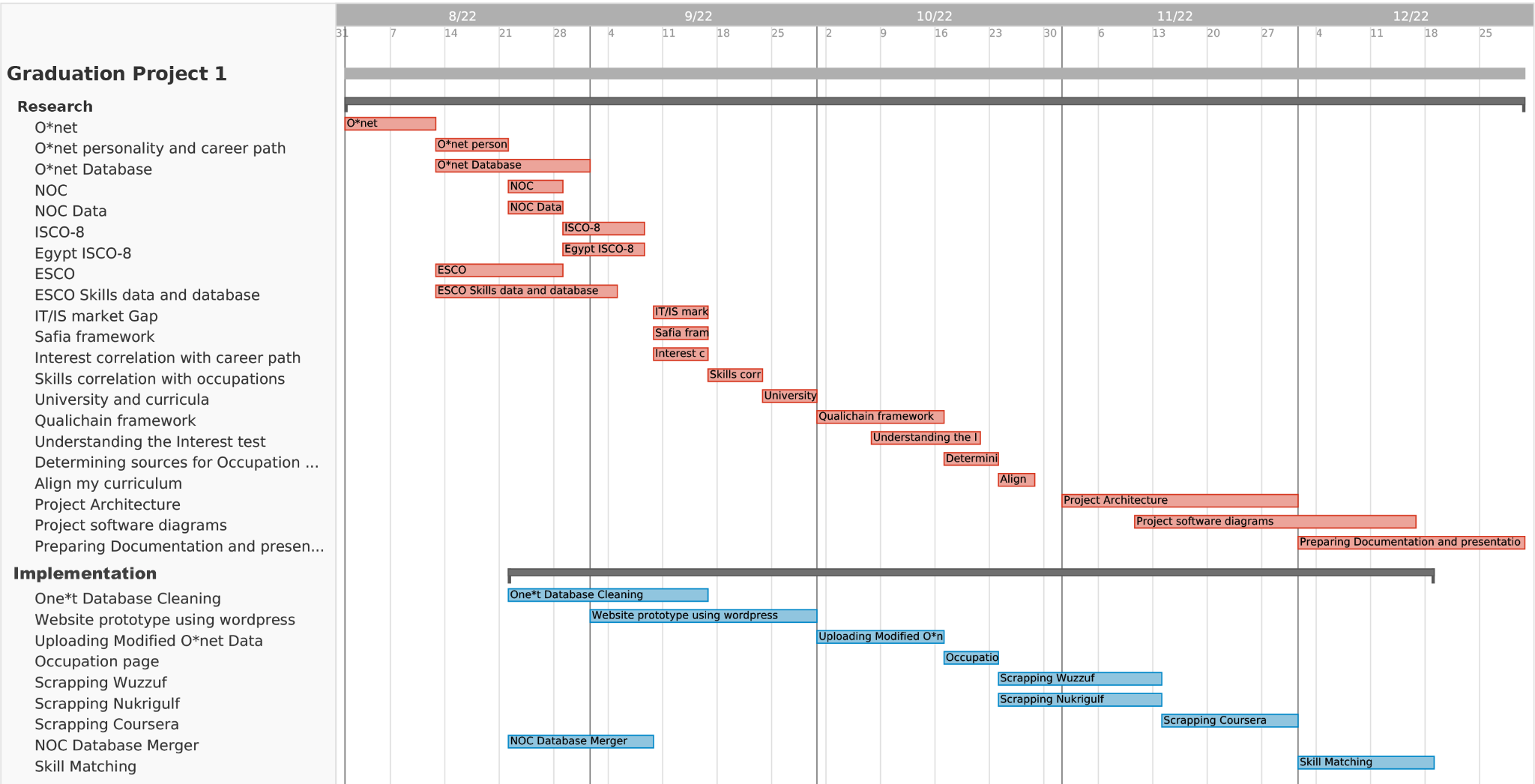

fig 3.2 Gantt Chart

###### Requirement planning

As explained, the RAD methodology demands constant updates and changes in the requirements, so with each meeting with the stakeholder, research is done to make sure the stakeholder's requirements can be implemented properly. This research is represented in the figure above with the red stripes. After an initial phase of research in the stakeholder's requirements, the first implementation is developed and is called the first prototype. The specifics of each prototype are specified in the section (PROTOTYPE) with screenshots of what was implemented.

#### The architecture of the framework:

An overview of the technical architecture, including the components and the modules within the components as well as the communication between the various modules. As shown in Figure 1, the framework consists of 6 primary modules (interface, Database, middleware, data analysis, similarity & matching module, and knowledge extraction ).

Shortly presented next:

**Interface:** Using WordPress tools and plugins to create the interface of the website and user interactivity, and communicating to it using APIs (snippets of code embedded in the module).

**Database:** This is a stand-alone service designed to handle all the data and respond to all queries by the middleware service.

**Middleware:** communicates with all services, receiving and sending requests in order to facilitate communication with the database and other services.

**Data analysis:** Using Hubspot integrated services provided by our sponsor. Its purpose is to provide insights into user behavior, website traffic, jobs, and skills.

**Skills matching:** This module is used to compare user skills and interests to the database and give occupational matching insights to the user.

**Knowledge Extraction:** The purpose of this module is to collect, process, and store data in the database. It is further divided into 5 components, a data collection and cleaning component, a skills extraction component, a classification component, and a matching component.

The below figure represents the structure of the system with each container representing an independent service and the arrows representing a RESTApi message.[31][32][33]

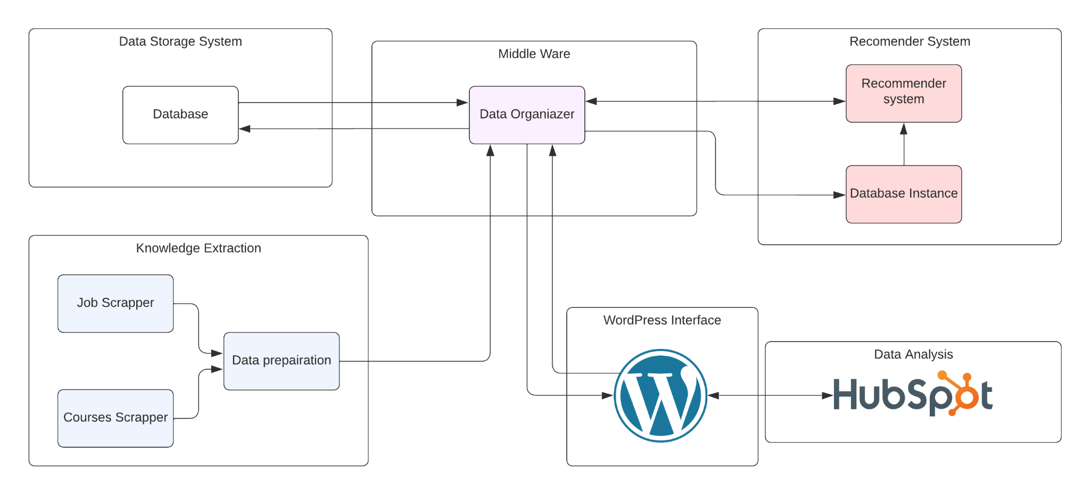

fig 3.3 Frame-work architecture

##### Interface

The interface of a WordPress website refers to the part of the website that users interact with when they visit the site. It includes the design, layout, and content that users see and interacts with within their web browser.

In WordPress, the interface is built using a combination of HTML, CSS, and JavaScript, which are used to structure and style the content and layout of the site. The interface is typically built using a theme, which is a collection of templates and styles that define the look and feel of the site.

The interface of a WordPress site may also include various features and functionalities, such as menus, search forms, and widgets, which allow users to navigate and interact with the site. These features are typically implemented using WordPress plugins, which are add-ons that extend the functionality of the WordPress platform.

Overall, the interface of a WordPress website is responsible for presenting the content and functionality of the site to users in a visually appealing and user-friendly way.

##### Database

At the center of this project is its database which is a relational database containing all the data for the system. A relational database arranges data into one or more tables where it is possible for the data to be connected to one another. The relational database's data can be created, modified, and extracted using the SQL programming language, which is also used to manage user access to the database. Along with relational databases and SQL, an RDBMS(Relational Database Management System) like MySQL works with an operating system to implement a relational database in a computer's storage system, manages users, permits network access, and makes it easier to test the integrity of the database and create backups.

The database management system used in the project is MySQL. This choice was based on the convenience provided by the O*net resource center as they provide an open source copy of their entire database using MySQL which allows adding modifications to the database a smoother process. Further more MySQL is an open-source RDBMS. An open-source database is any database application with a codebase that is free to view, download, modify, distribute, and reuse.

##### Middleware

A category of computer software that facilitates communications with software applications and can relieve them from functions that may complicate the communication process. It's often referred to as "software glue." In the case of this project, what is used is database middleware. Direct contact with databases and direct access to data structures are made possible by database middleware. Database gateways and a range of connecting methods are available. [1]

In the below figure, the middleware is able to receive requests from the other services and query the database to get the relevant information, this information is sent back to the service as the response.

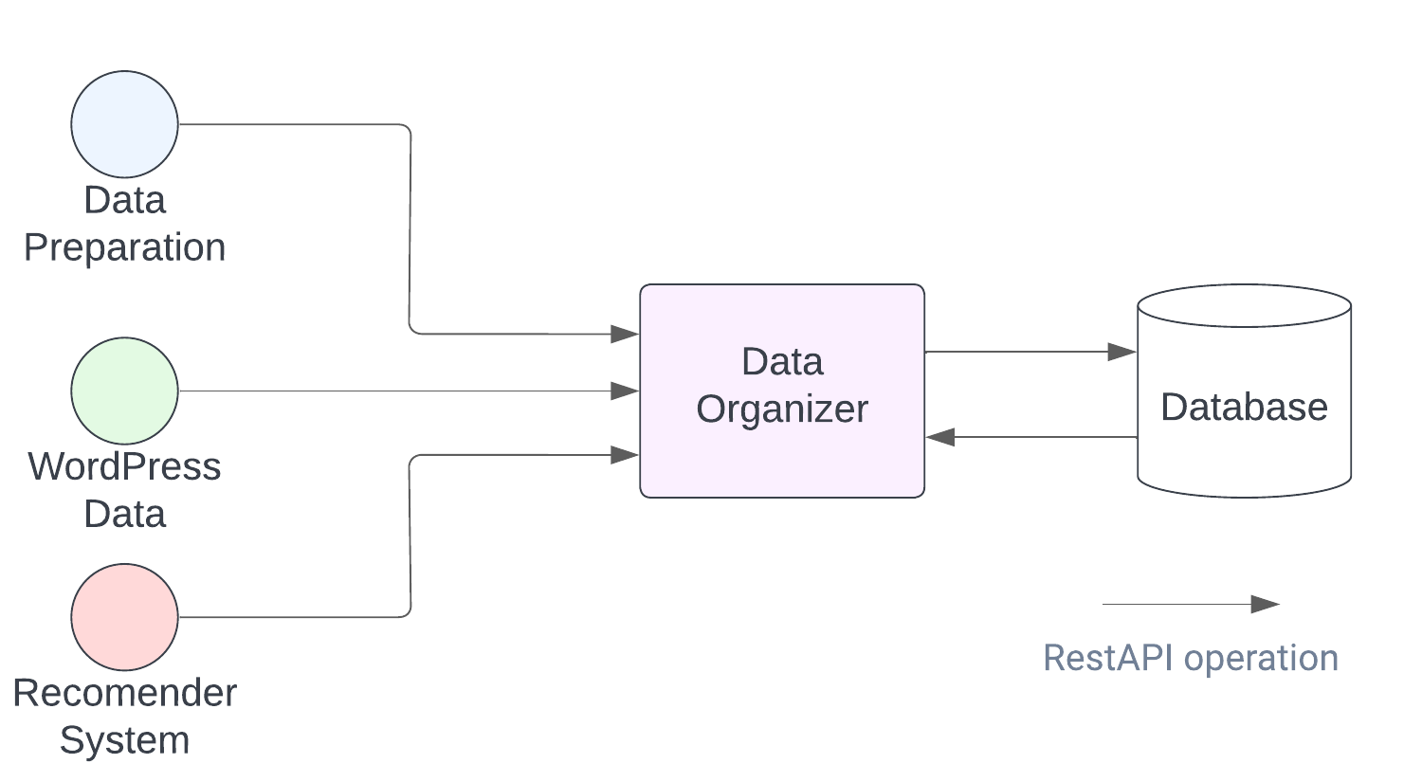

fig 3.4

##### Data analysis (HubSpot)

Integrating HubSpot with WordPress is a straightforward process that allows us to easily access and use HubSpot's tools and features within our WordPress website dashboard.

The WordPress HubSpot plugin provides an overall analysis of the website’s performance through various capabilities:

* Improved lead generation: By integrating HubSpot with WordPress, we can easily add forms and pop-ups to our site to capture leads. We can also use HubSpot's tools to create personalized calls-to-action (CTAs) and track the performance of our forms.
* Enhanced marketing automation: HubSpot's marketing automation tools allow us to create personalized email campaigns and automated workflows based on user behavior. We can trigger these campaigns based on actions taken by users on our WordPress site.
* Better customer relationship management: HubSpot's CRM allows you to track and manage interactions with leads and customers. We can easily see which pages on our site our leads and customers are visiting and use this information to improve our sales and marketing efforts.
* Improved analytics and reporting: HubSpot's analytics and reporting tools give us insights into the performance of your marketing and sales efforts. By integrating HubSpot with WordPress, we can easily see how our website is contributing to our overall business goals.
* Improved efficiency: Integrating HubSpot with WordPress allows us to manage our marketing and sales efforts from a single platform, rather than using multiple tools. This can save you time and improve the efficiency of our workflow.

Overall, integrating HubSpot with WordPress allows us to better capture and manage leads, automate marketing efforts, improve customer relationships, and track the performance of our website.

##### Skills Matching

The skills matching module uses a retrieval model based on set theory and boolean algebra. User skills are designed as boolean expressions which have precise semantics. The retrieval strategy is based on binary decision criteria. The boolean model considers that index skills are present or absent in an occupation.

##### 

fig 3.5

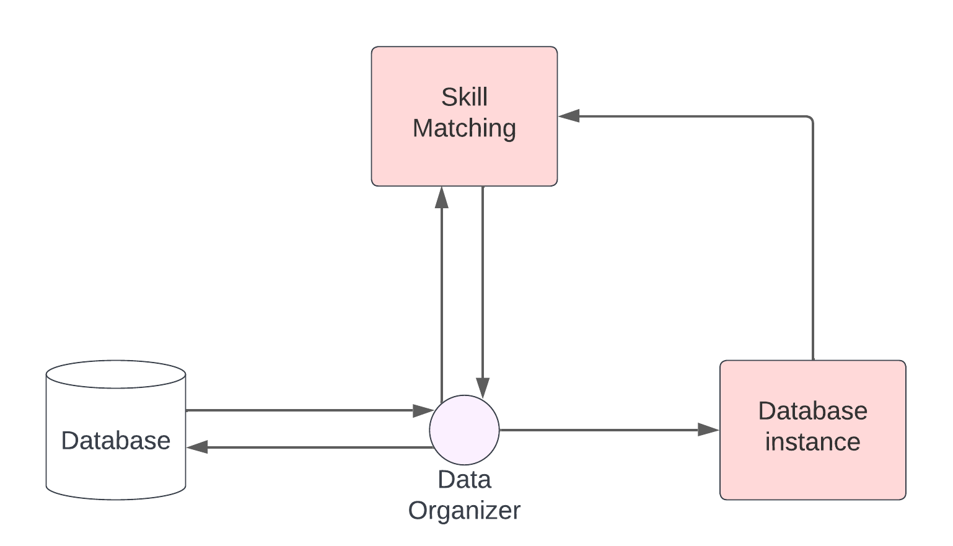

fig 3.6

Each time the database is updated with new job market data the data organizer sends a new instance of the data to the database instance to store an instance of the new data. This allows the skills matching module to be far more efficient and does not have to wait for the occupations data from the data organizer each time a new set of skills is requested to be compared.

##### Knowledge extraction

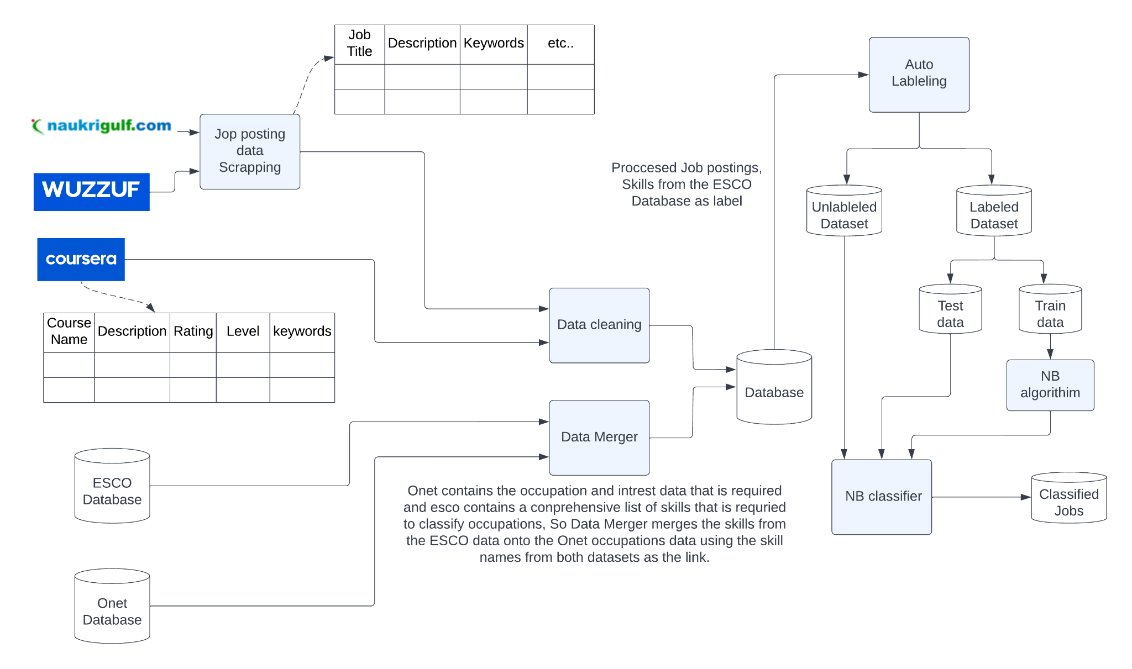

fig 3.7

components:

* Data collection and cleaning
* Skill extraction
* Classification

###### Data collection and preprocessing component

This component is used as a source of information. as our project is tailored to the Egyptian Student and labor markets, we have to ensure that this data is appropriately represented.

**Data collection:** refers to two data sources (job postings and courses) that were scraped from online job postings and courses from online course platforms.

**Data cleaning:** In this part, we will transfer the noisy, raw data into clean, meaningful, topic-related data by removing duplicates and dropping unrelated fields.

###### Skills Extraction:

As skills are a centric part of our project skills so in this module we extract skills required from job_postings and skills acquired from courses and curricula

###### Classification

In this component, we use the Naive Bayes classifier to classify unlabeled jobs that have no match with O*NET occupations.

Reason for choosing Naive Bayes:

Naive Bayes is a straightforward, simple algorithm that works very well with large data sets, needs little training data, and requires little time to be built. Each attribute contributes to the final decision equally and independently, and it has been proven that Naive Bayes is better at text classification than other classifiers such as NN and Decision Tree.

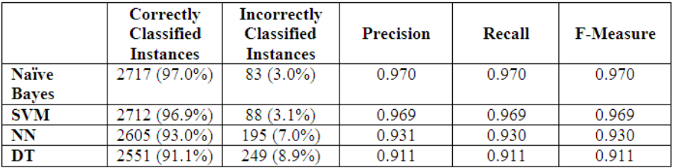

fig 3.8

As the above figure shows, the naive Bayes classifier performs better on text classification compared to the SVM, NN, and DT classifiers. [27][28][29]

#### Requirement Analysis

This section is a collection of all the requirements from the stakeholders. It is used as a guideline in the development of most diagrams in the next sections.

###### Functional Requirements

table 3.1 Student Register [SR]

| **Requirement ID** | **Requirement description** |
| --- | --- |
| SR-1 | If the user does not have an account, they click the register button and be taken to the registration screen. |
| SR-2 | The user enters his name, email, college, skills, and password. Skills and college fields are optional and can be changed later in the profile menu. |
| SR-3 | In the registration screen a new user types in all of their information and clicks submit, the data is then validated to make sure there is not an existing user with those credentials. If there is an existing user, the user is asked to enter a new username. If there is no conflict with the credentials then the user is registered and is sent an email to verify the registration. |

table 3.2 Student Login [SL]

| **Requirement ID** | **Requirement description** |
| --- | --- |
| SL-1 | The login screen allows registered users to log in to the site to access all the features their account gives them access to. |
| SL-2 | If they are incorrect they get an error message |
| SL-3 | If the user has forgotten their password they click "Forgot Password?" which takes them to a password recovery screen. If the user does not have an account then they click the register button and be taken to the registration screen |

table 3.3 Student Navigation [SN]

| **Requirement ID** | **Requirement description** |
| --- | --- |
| SN-1 | A navigation bar is present on all pages of the website. |
| SN-2 | The user is able to go back and forth throughout the website using the navigation bar buttons. |
| SN-3 | The User is able to access the “Home”, “Manage Profile”, “Recommended occupations”, “Courses”, and “Skills” menus from the navigation bar |

table 3.4 Student Manage skills [SMS]

| **Requirement ID** | **Requirement description** |
| --- | --- |
| SMS-1 | The user is able to add skills to his profile. |
| SMS-2 | The user is able to edit skills on his profile. |
| SMS-3 | The user is able to remove skills from his profile. |
| SMS-4 | The user is able to see a list of skills for each occupation. |
| SMS-5 | The user is able to click on a skill to view its description and a list of courses, occupations, and curriculums associated with that skill. |

table 3.5 View Occupations [VO]

| **Requirement ID** | **Requirement description** |
| --- | --- |
| VO-1 | The user is able to see a list of occupations with their matching rate. |
| VO-2 | The user is able to click on an occupation to view its description and skills required |

Interest Test

table 3.6 Interest Test [IT]

| **Requirement ID** | **Requirement description** |
| --- | --- |
| IT-1 | The “Take Test” button allows the user to take a test to determine their interest based on a series of questions that the user answers. |
| IT-2 | After finishing the test the user’s results are displayed. |
| IT-3 | The user’s test answers and results are saved in the database |

table 3.7 Get Occupations [GO]

| **Requirement ID** | **Requirement description** |
| --- | --- |
| GO-1 | System must be able to collect information about occupations. |
| GO-2 | Systems must be able to process and categorize occupations. |
| GO-3 | Store processed data. |

table 3.8 Compare Skills [CS]

| **Requirement ID** | **Requirement description** |
| --- | --- |
| CS-1 | The system compares user skills with occupation skills. |
| CS-2 | Display the match percentage between user skills and occupation skills. |

table 3.9 View Dashboard [VD]

| **Requirement ID** | **Requirement description** |
| --- | --- |
| VD-1 | The admin is able to explore the dashboard and get insights about the website statistics. |

table 3.10 Manage Occupations [MO]

| **Requirement ID** | **Requirement description** |
| --- | --- |
| MO-1 | The admin is able to add new occupations |
| MO-2 | The admin is able to edit occupations |
| MO-3 | The admin is able to remove occupations |

table 3.11 Manage Skills [MS]

| **Requirement ID** | **Requirement description** |
| --- | --- |
| MS-1 | The admin is able to add new skills |
| MS-2 | The admin is able to edit skills |
| MS-3 | The admin is able to remove skills |

table 3.12 Manage Courses [MCO]

| **Requirement ID** | **Requirement description** |
| --- | --- |
| MC-1 | The admin is able to add new courses |
| MCO-2 | The admin is able to edit courses |
| MCO-3 | The admin is able to remove courses |

table 3.13 Super Admin Manage Privileges [SAMP]

| **Requirement ID** | **Requirement description** |
| --- | --- |
| SAMP-1 | The super admin is able to view a list of all the users of the system. |
| SAMP-2 | The super admin is able to edit the profile attributes of all users. |
| SAMP-3 | The super admin is able to remove any user from the system. |
| SAMP-4 | The super admin is able to find any user |
| SAMP-5 | Super admin is able to view logs of all users |
| SAMP-6 | find log records |

table 3.14 Sub-Admin Manage Privileges [SUAMP]

| **Requirement ID** | **Requirement description** |
| --- | --- |
| SUAMP-1 | The sub-admin is able to view a list of all the student users of the system. |
| SUAMP-2 | The sub-admin can edit all student users' profile attributes. |
| SUAMP-3 | The sub-admin is able to remove any user from the system. |
| SUAMP-4 | The sub-admin is able to find any student. |

table 3.15 Maintain Logs [SL]

| **Requirement ID** | **Requirement description** |
| --- | --- |
| ML-1 | A system log should be maintained at all times to keep track of all admin activities. |

###### Nonfunctional Requirements

**Usability Requirements**

System should be user-friendly so that students can interact easily with

it and shouldn’t waste time learning how to use or remember its services so

the system should be clear as we can.

**Speed Requirements**

screen refresh time shouldn’t take more than 3 seconds, the data

transfer should be as fast as we can and the process of profile creation shouldn’t take much time.

**Reliability Requirements**

The system should be structured as small independent components

that can help us to have a very small failure rate.

**Robustness Requirements**

System should take less than 30 seconds to restart if any failure

occurs, so we should take into consideration all possible interactions that can

cause the failure, and even if one component fails other don’t and the system

meets the user's needs.

#### Use Cases & Use Case Narrative

Use cases are used to display how the users of the system may interact with it. the use case narrative is then an explanation of the use case itself since most use cases below are clearly defined in the functional requirements, the use case narrative resorts to explaining the ambiguous use cases.

##### Use case

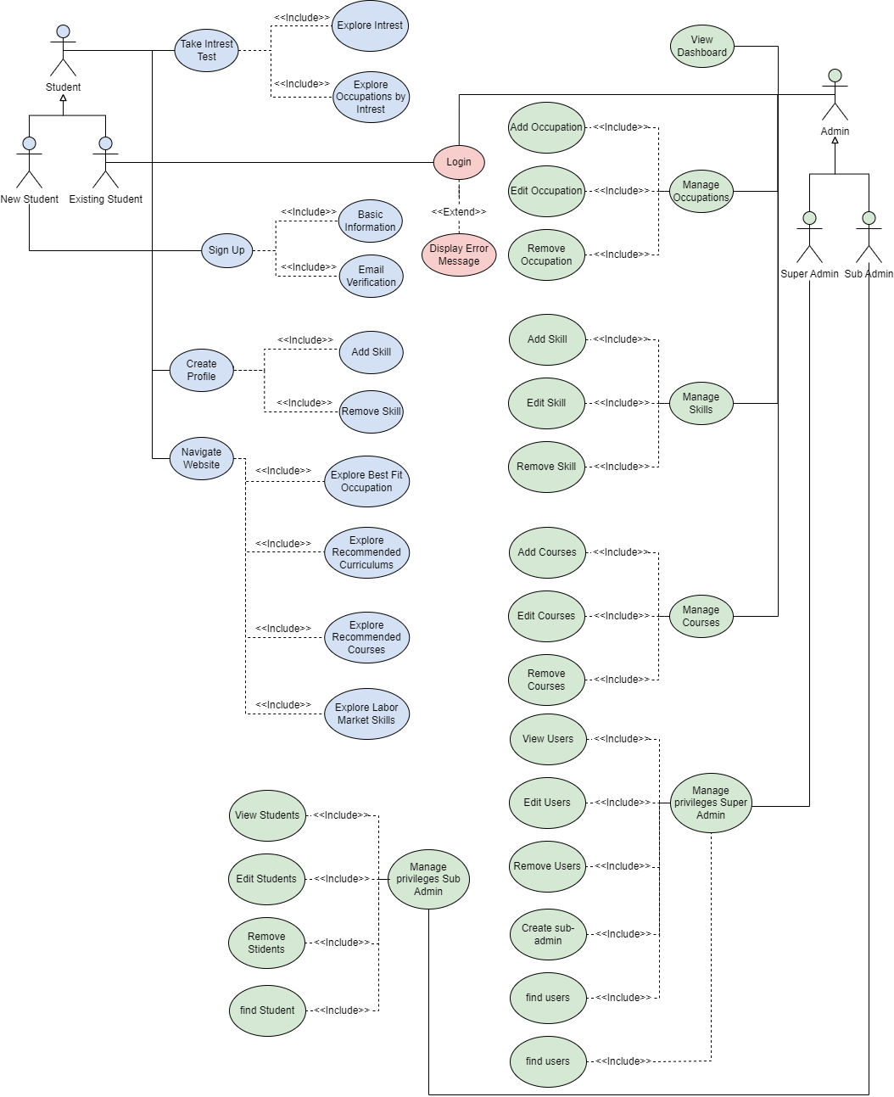

fig 3.9

##### Use case narrative

1. registration

| ID | 1 |
| --- | --- |
| use case name | registration |
| Goal of context | Student can register to be our client |
| precondition | - |
| trigger | Student wants our Guide in his career |
| primary actor | Student |
| Scenario | student has to fill our registration form  student has to set his password  student has to confirm registration  system will save the information |
| postcondition | user has to validate his account through E-mail |

table 3.16

1. login

| ID | 2 |
| --- | --- |
| use case name | login |
| Goal of context | student can log in to our system |
| precondition | student has registered |
| trigger | Student wants to access his account |
| primary actor | Student |
| Scenario | student has to fill our registration form  student has to set his password  student has to confirm registration  system will save the information |
| postcondition | system will start the session |

table 3.17

1. create profile

| ID | 3 |
| --- | --- |
| use case name | profile creation |
| Goal of context | student can create a profile to start building his journey |
| precondition | student has logged in |
| trigger | students want to explore best-fit jobs |
| primary actor | Student |
| Scenario | -student has to fill our his skills  -the system will calculate the similarity between his skills and occupation  -the system will recommend best fit occupation for him based on skills |
| postcondition | -courses and curriculums recommendation |

table 3.18

1. personality test

| ID | 4 |
| --- | --- |
| use case name | personality test |
| Goal of context | student will find the type of his personality |
| pre-condition | student has logged in |
| trigger | students want to explore best-fit jobs for him based on personality |
| primary actor | Student |
| Scenario | * the student will answer the test Questions * the system will calculate the similarity between his answers and personality types * the system will show his personality * the system will recommend the best fit occupations based on his personality |
| postcondition | courses and curriculums recommendation |

table 3.19

#### Data Flow Diagram

The data flow diagram is divided into levels each level getting progressively deeper into the processes of the system.

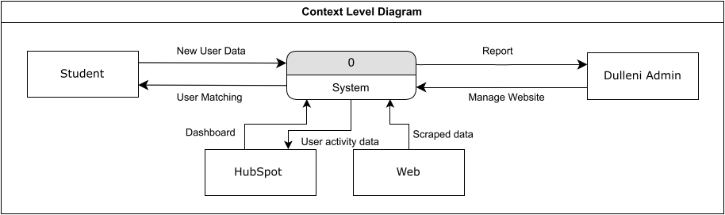

Fig 3.10

The context level diagram is the first level of the data flow diagram and it represents the system and the connections between it and the external entities from which it sends or receives data from.

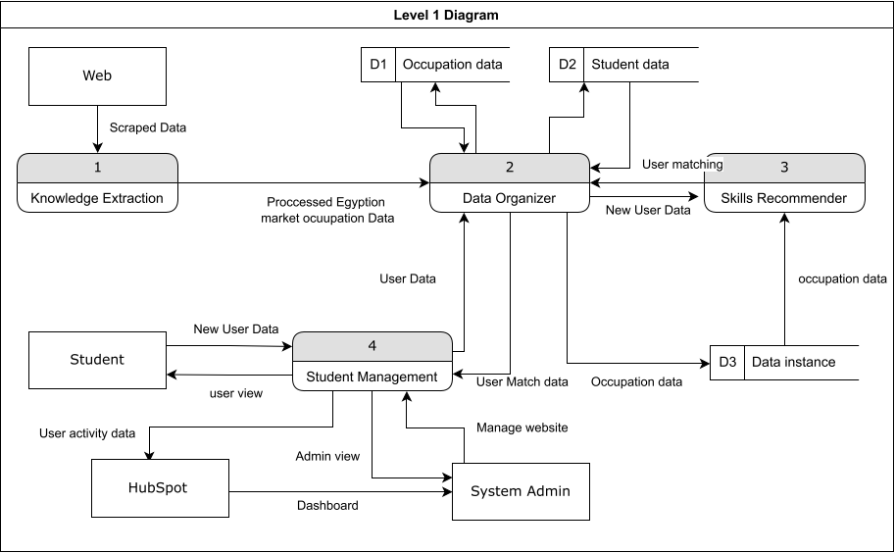

Fig 3.11

The level 1 diagram expands the system to reveal 4 main processes in it. This process represents the main operations of the system.

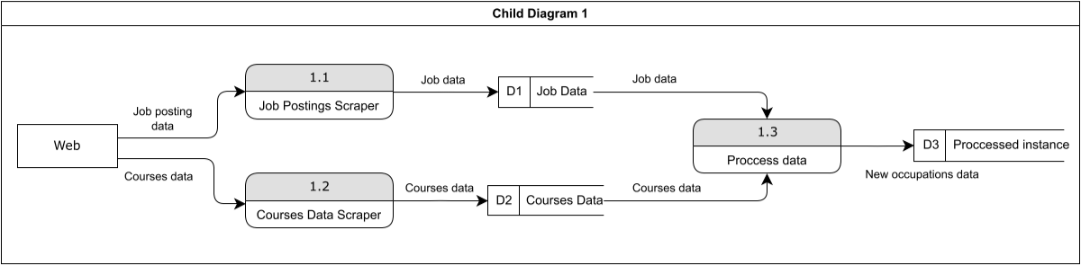

Fig 3.12

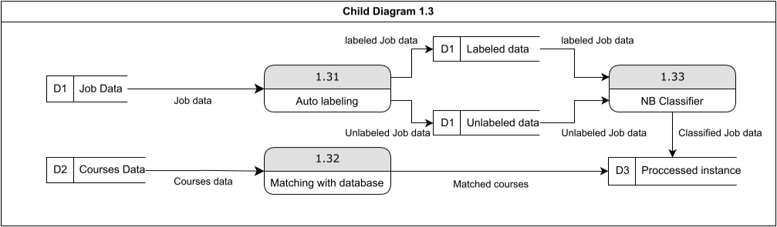

Fig 3.13

Child diagrams 1 and 1.3 represent the data processing part of the project.

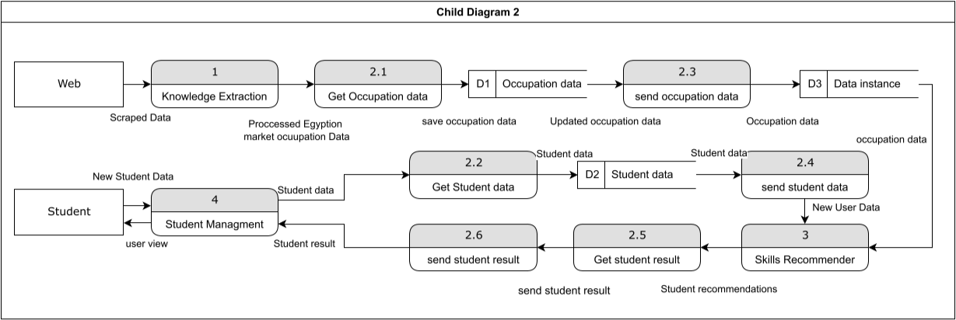

Fig 3.14

Child diagram 2 represents the student skills matching part of the system.

Child diagram 4 represents the system processes with the student and admin users.

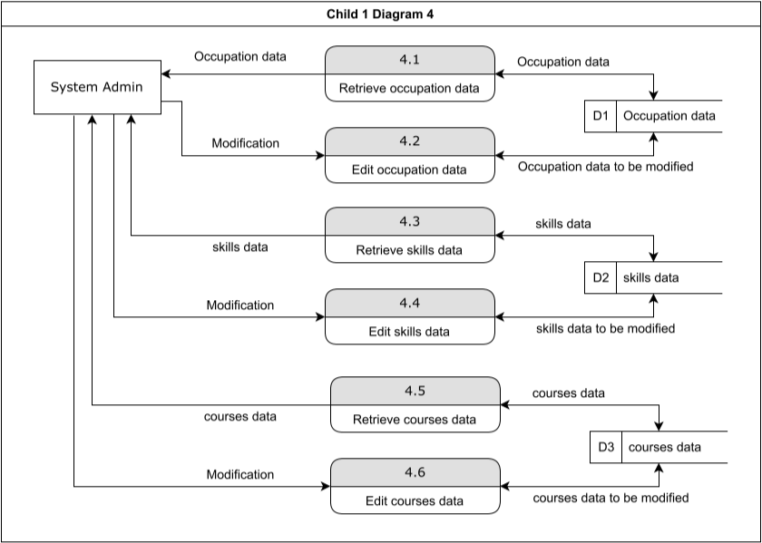

Fig 3.15

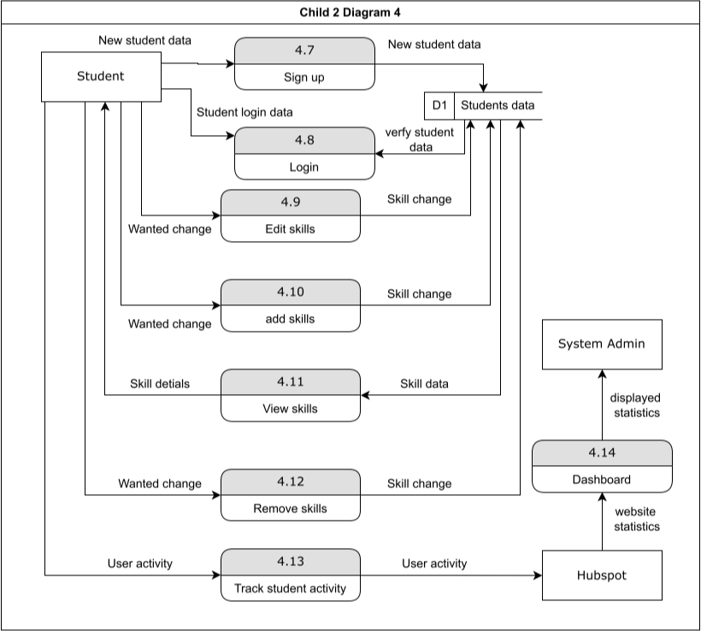

Fig 3.16

#### Sequence Diagram

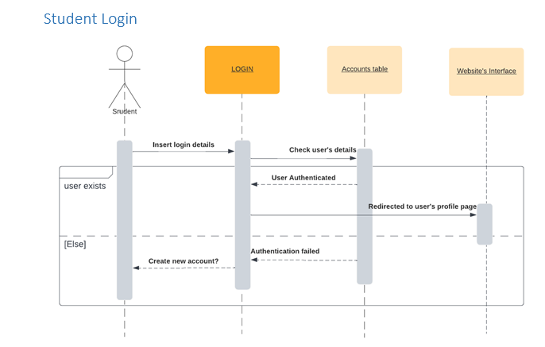

Fig 3.17

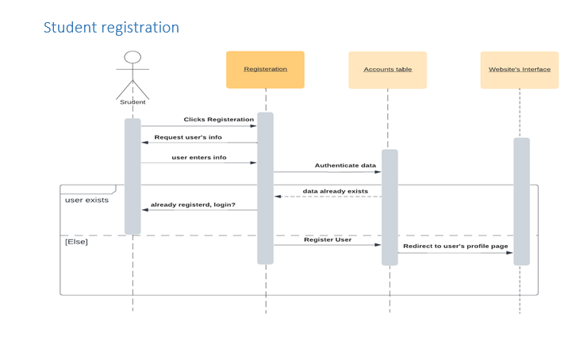

Fig 3.18

#### 

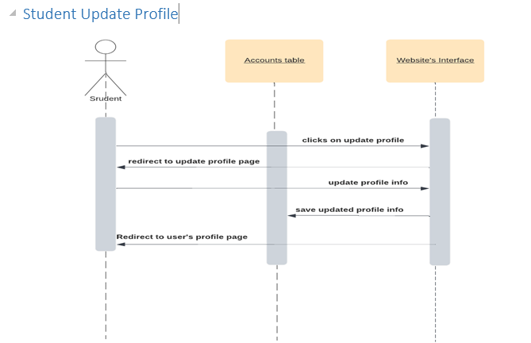

Fig 3.19

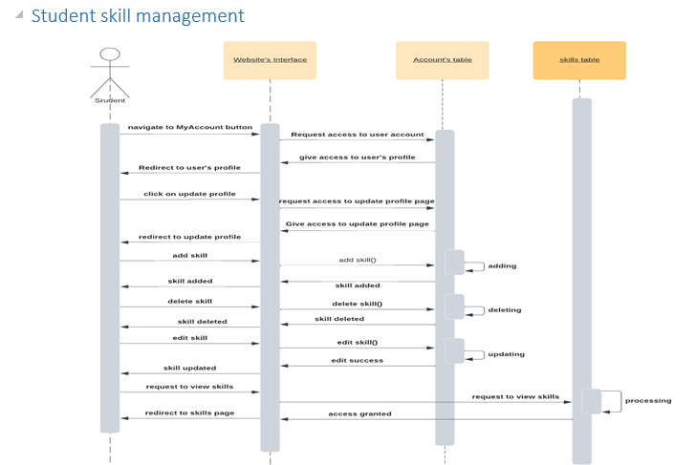

Fig 3.20

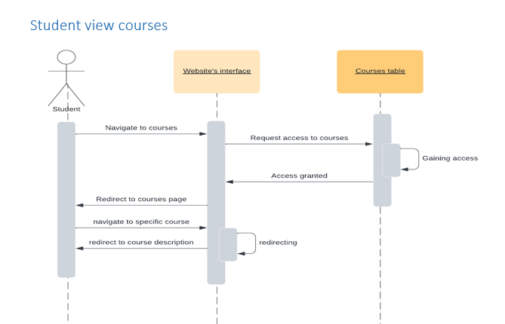

Fig 3.21

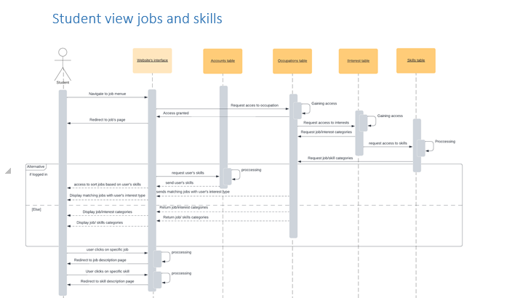

Fig 3.22

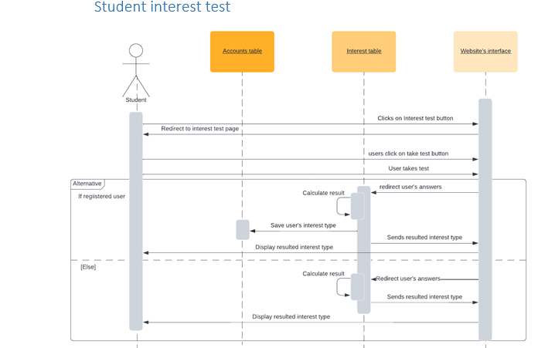

Fig 3.23

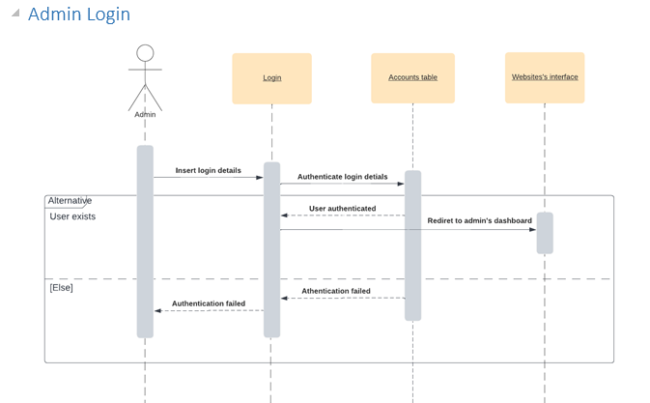

Fig 3.24

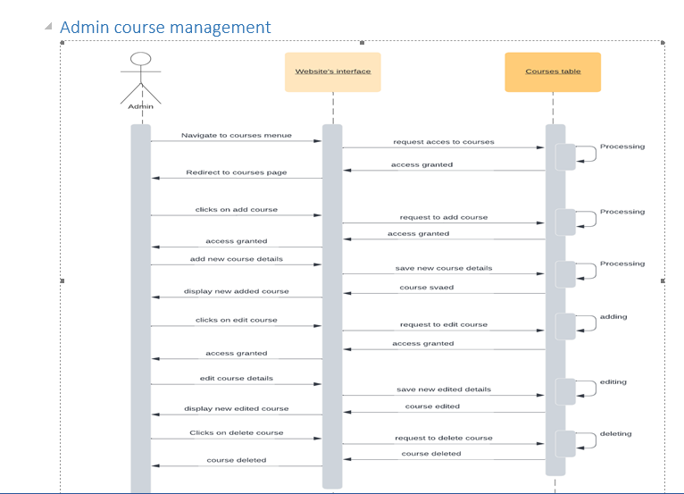

Fig 3.25

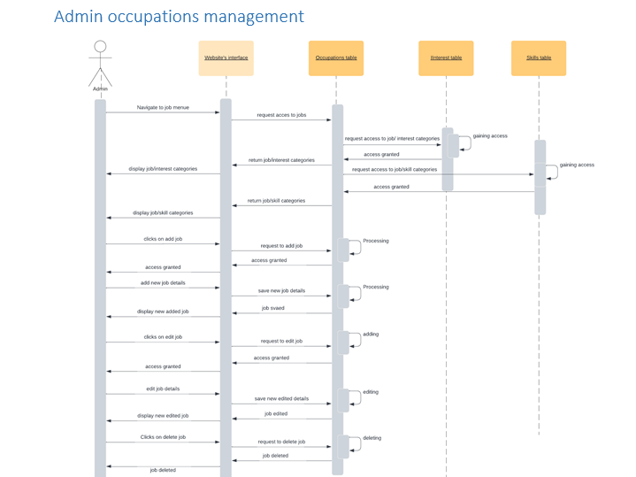

Fig 3.26

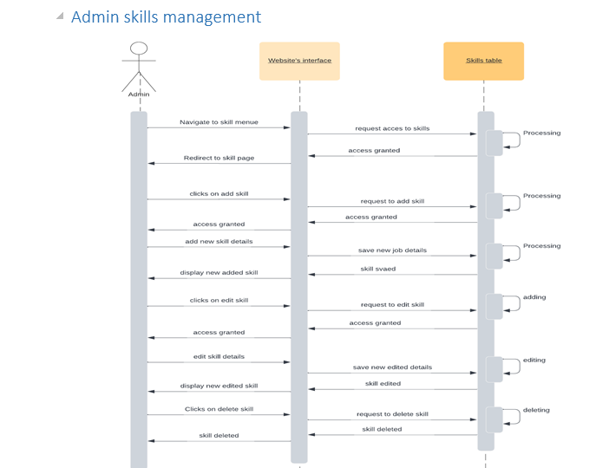

Fig 3.27

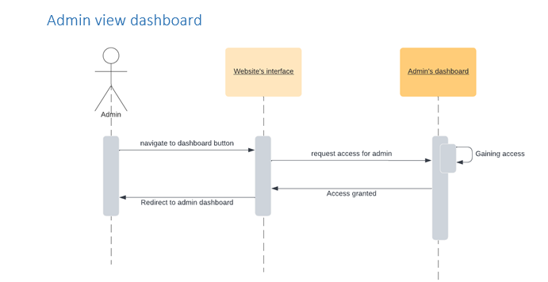

Fig 3.28

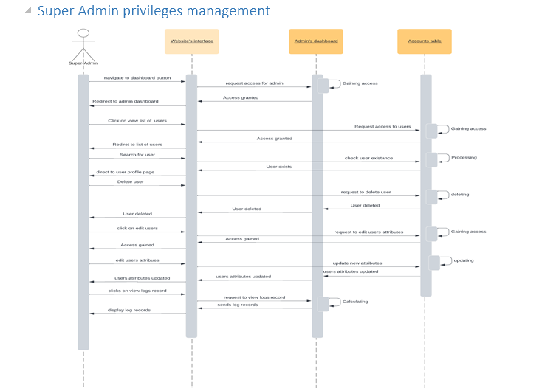

Fig 3.29

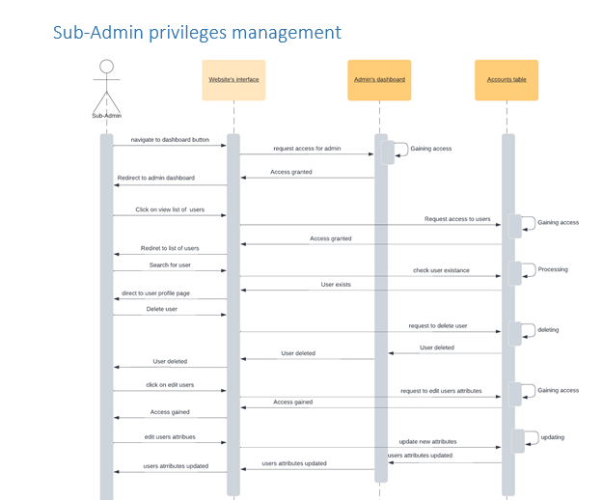

Fig 3.30

#### Entity Relationship Diagram

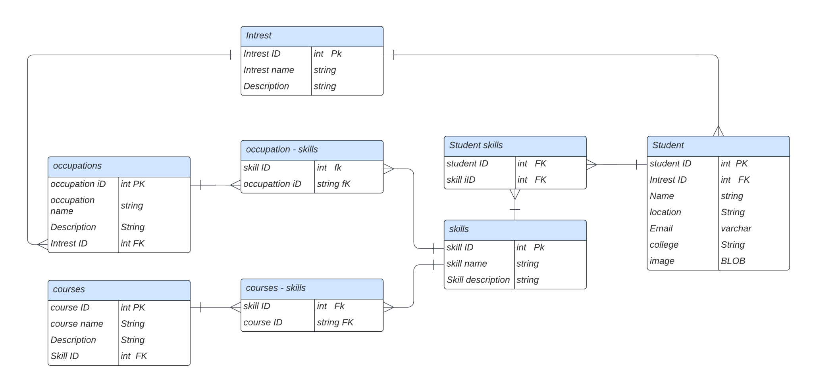

Fig 3.31

### Chapter four: results and discussion

#### Prototype photos

**Registration Page:**

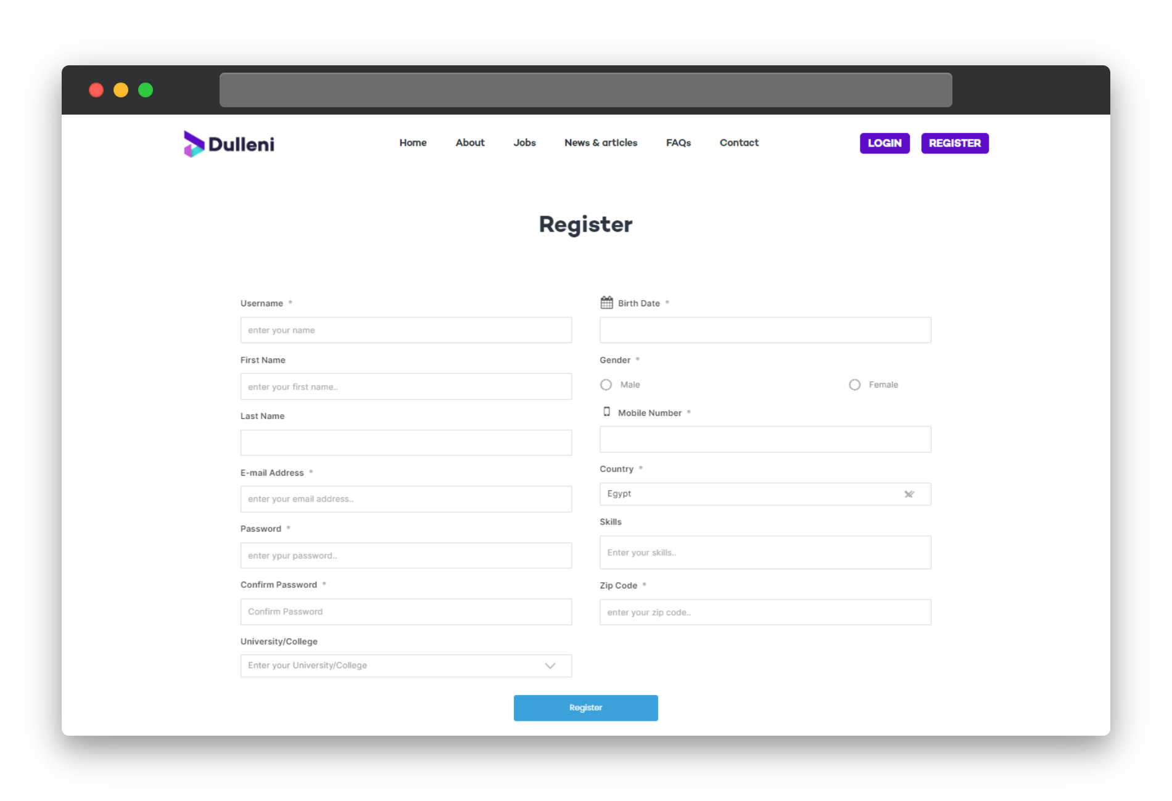

Fig 4.1

**Login Page:**

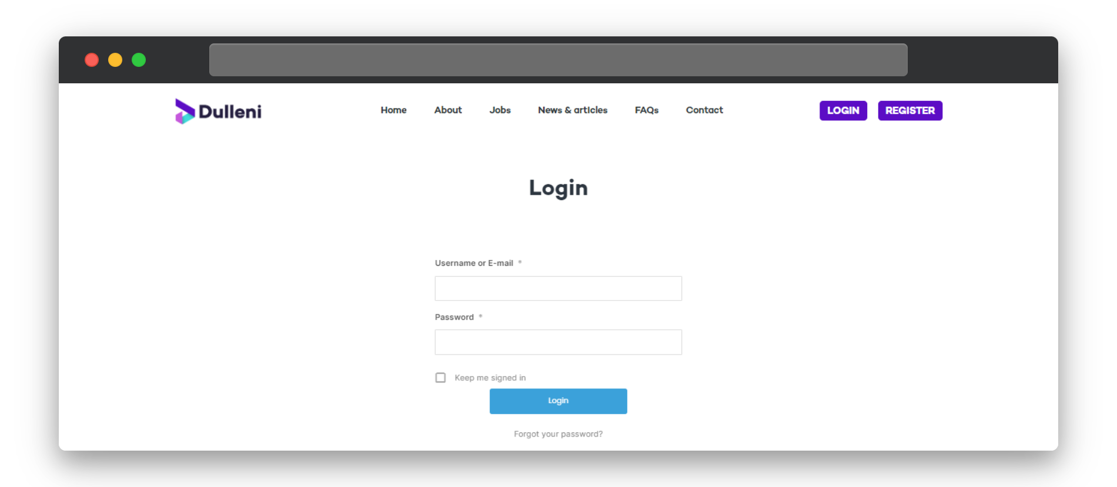

Fig 4.2

**Home Page:**

Fig 4.3

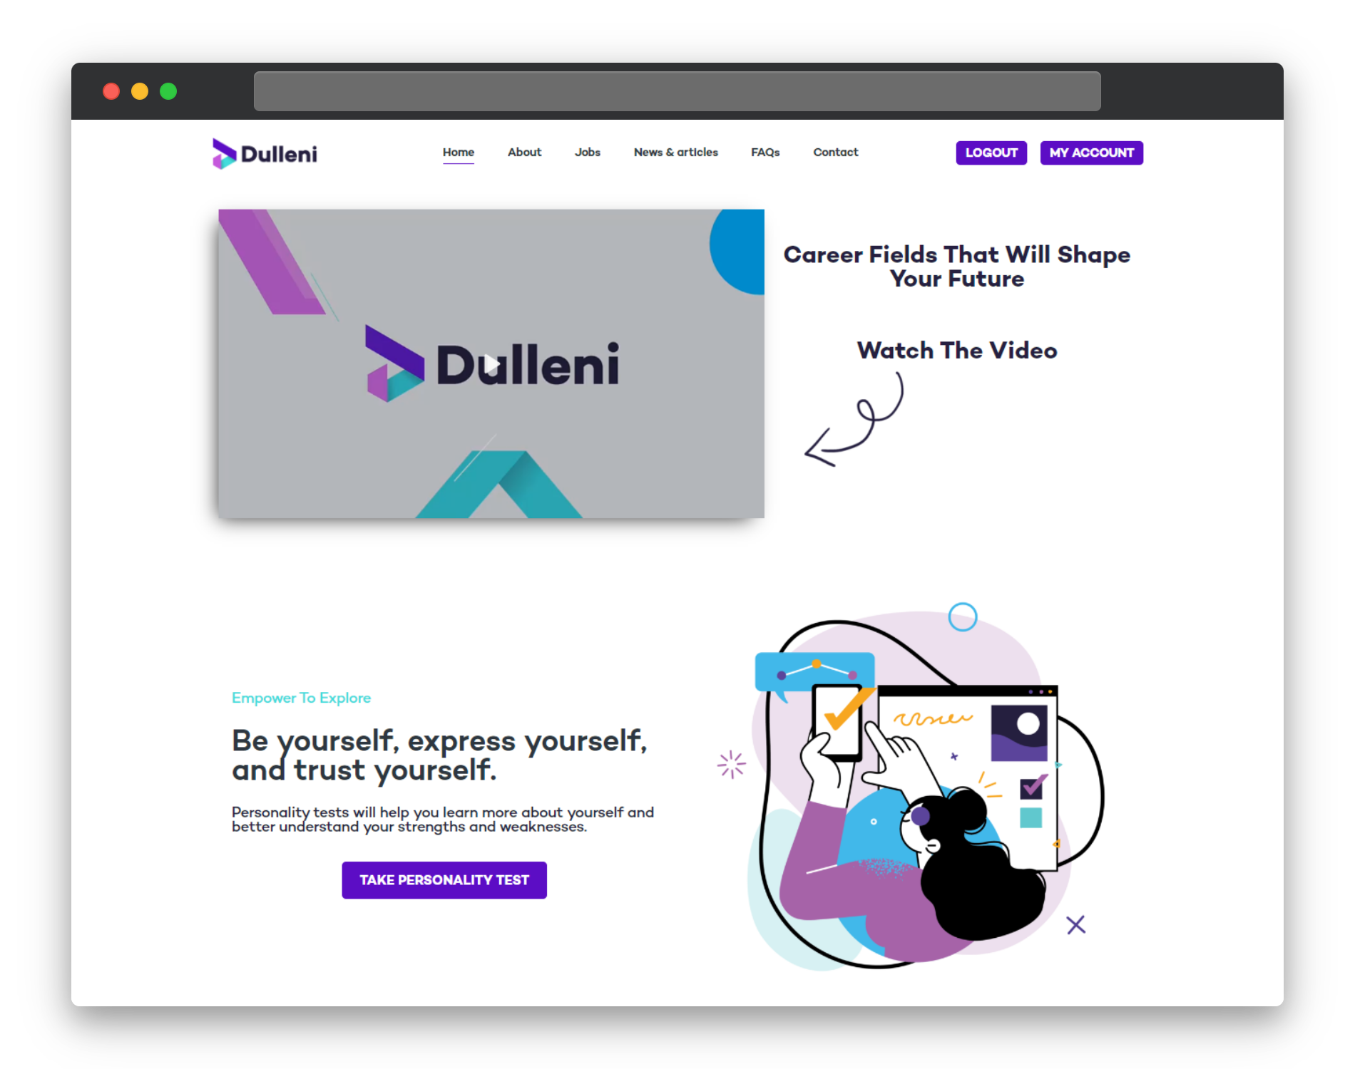

Fig 4.4

**Test Page:**

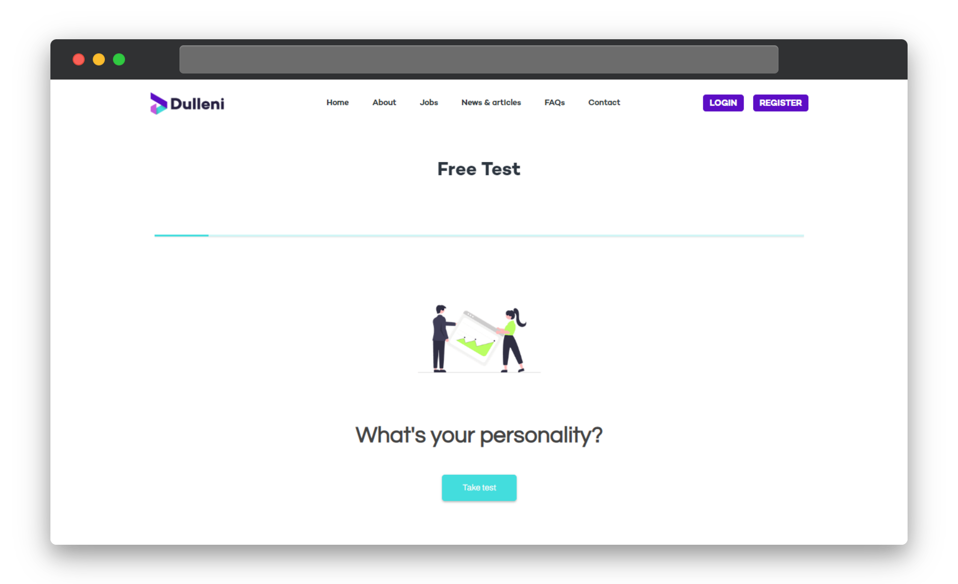

Fig 4.5

**Test:**

##### 

Fig 4.6

**Result Page:**

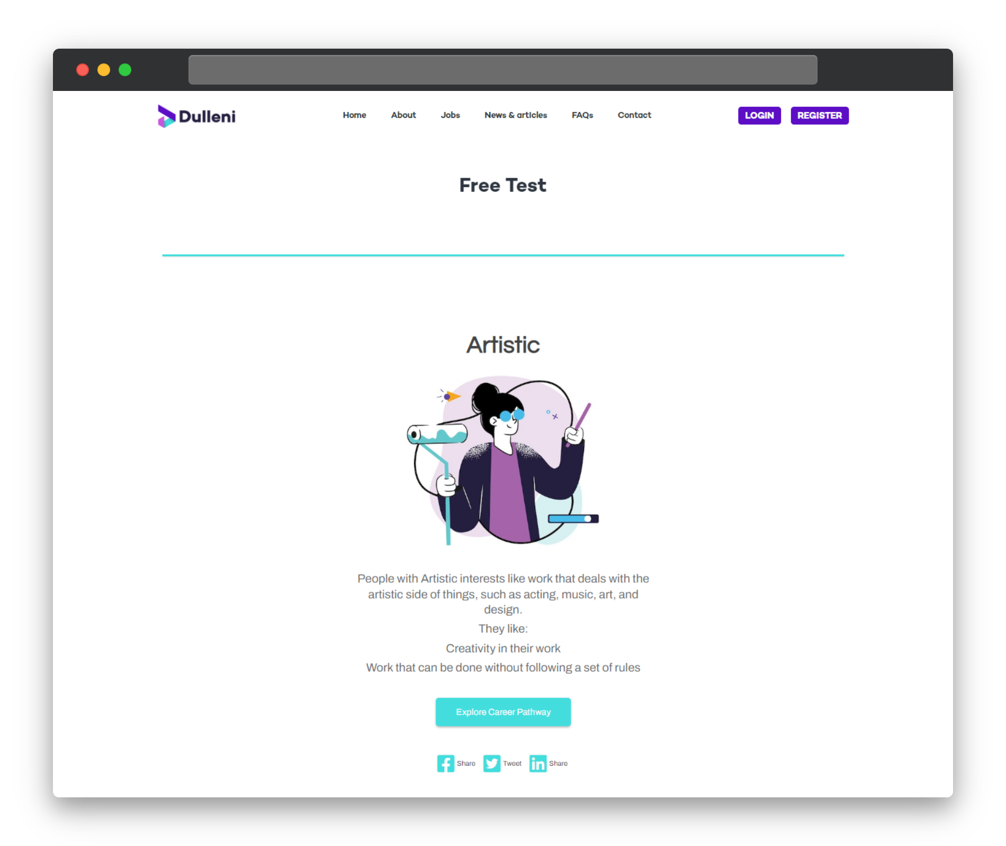

Fig 4.7

**Profile page:**

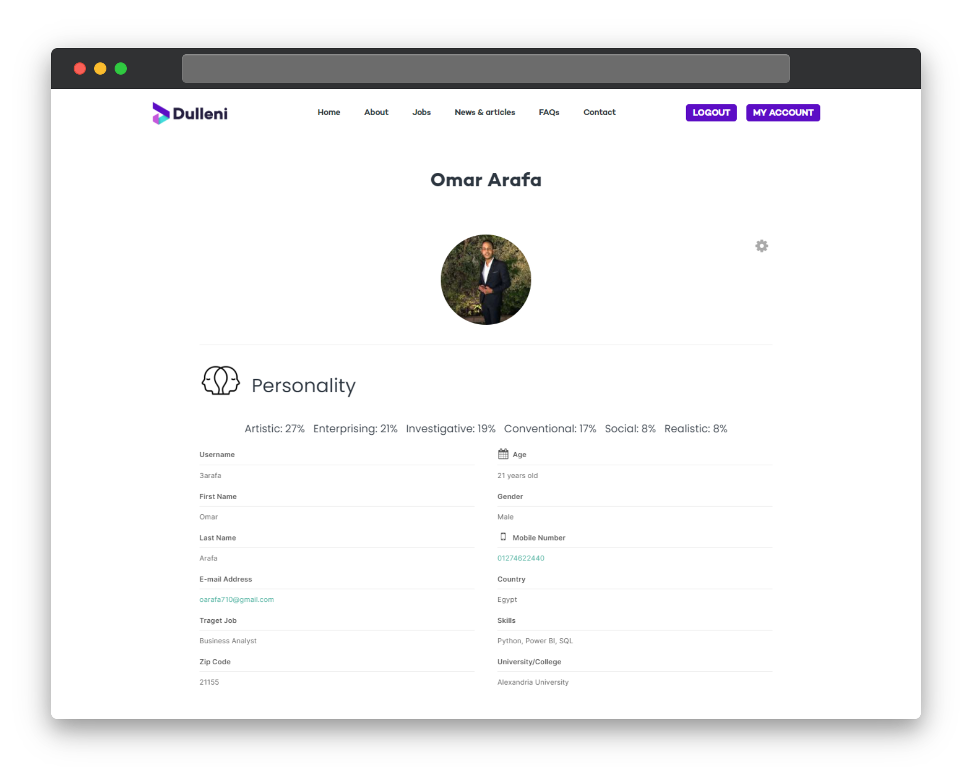

Fig 4.8

**Jobs Page:**

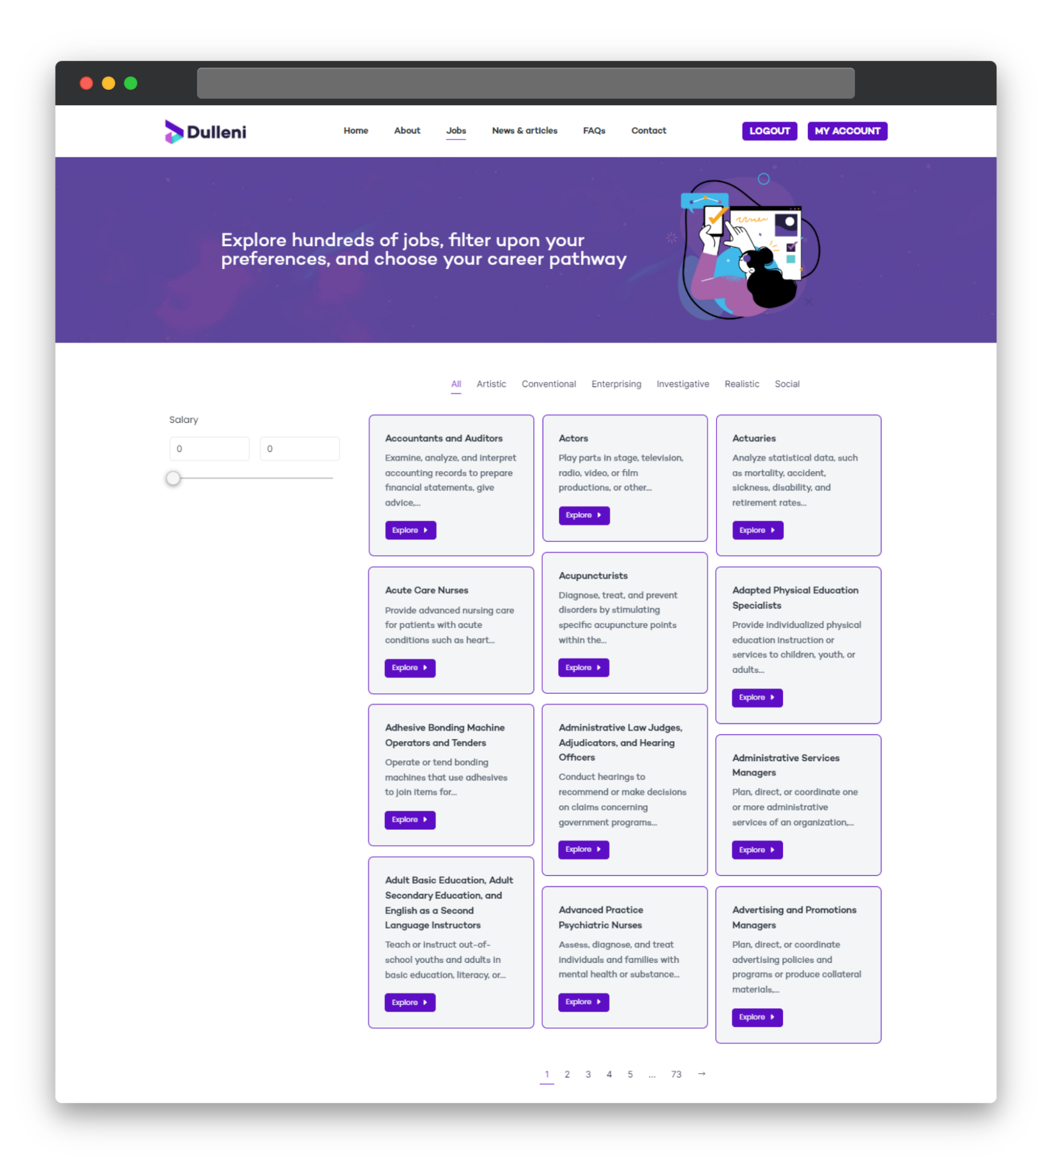

Fig 4.9

**Jobs single:**

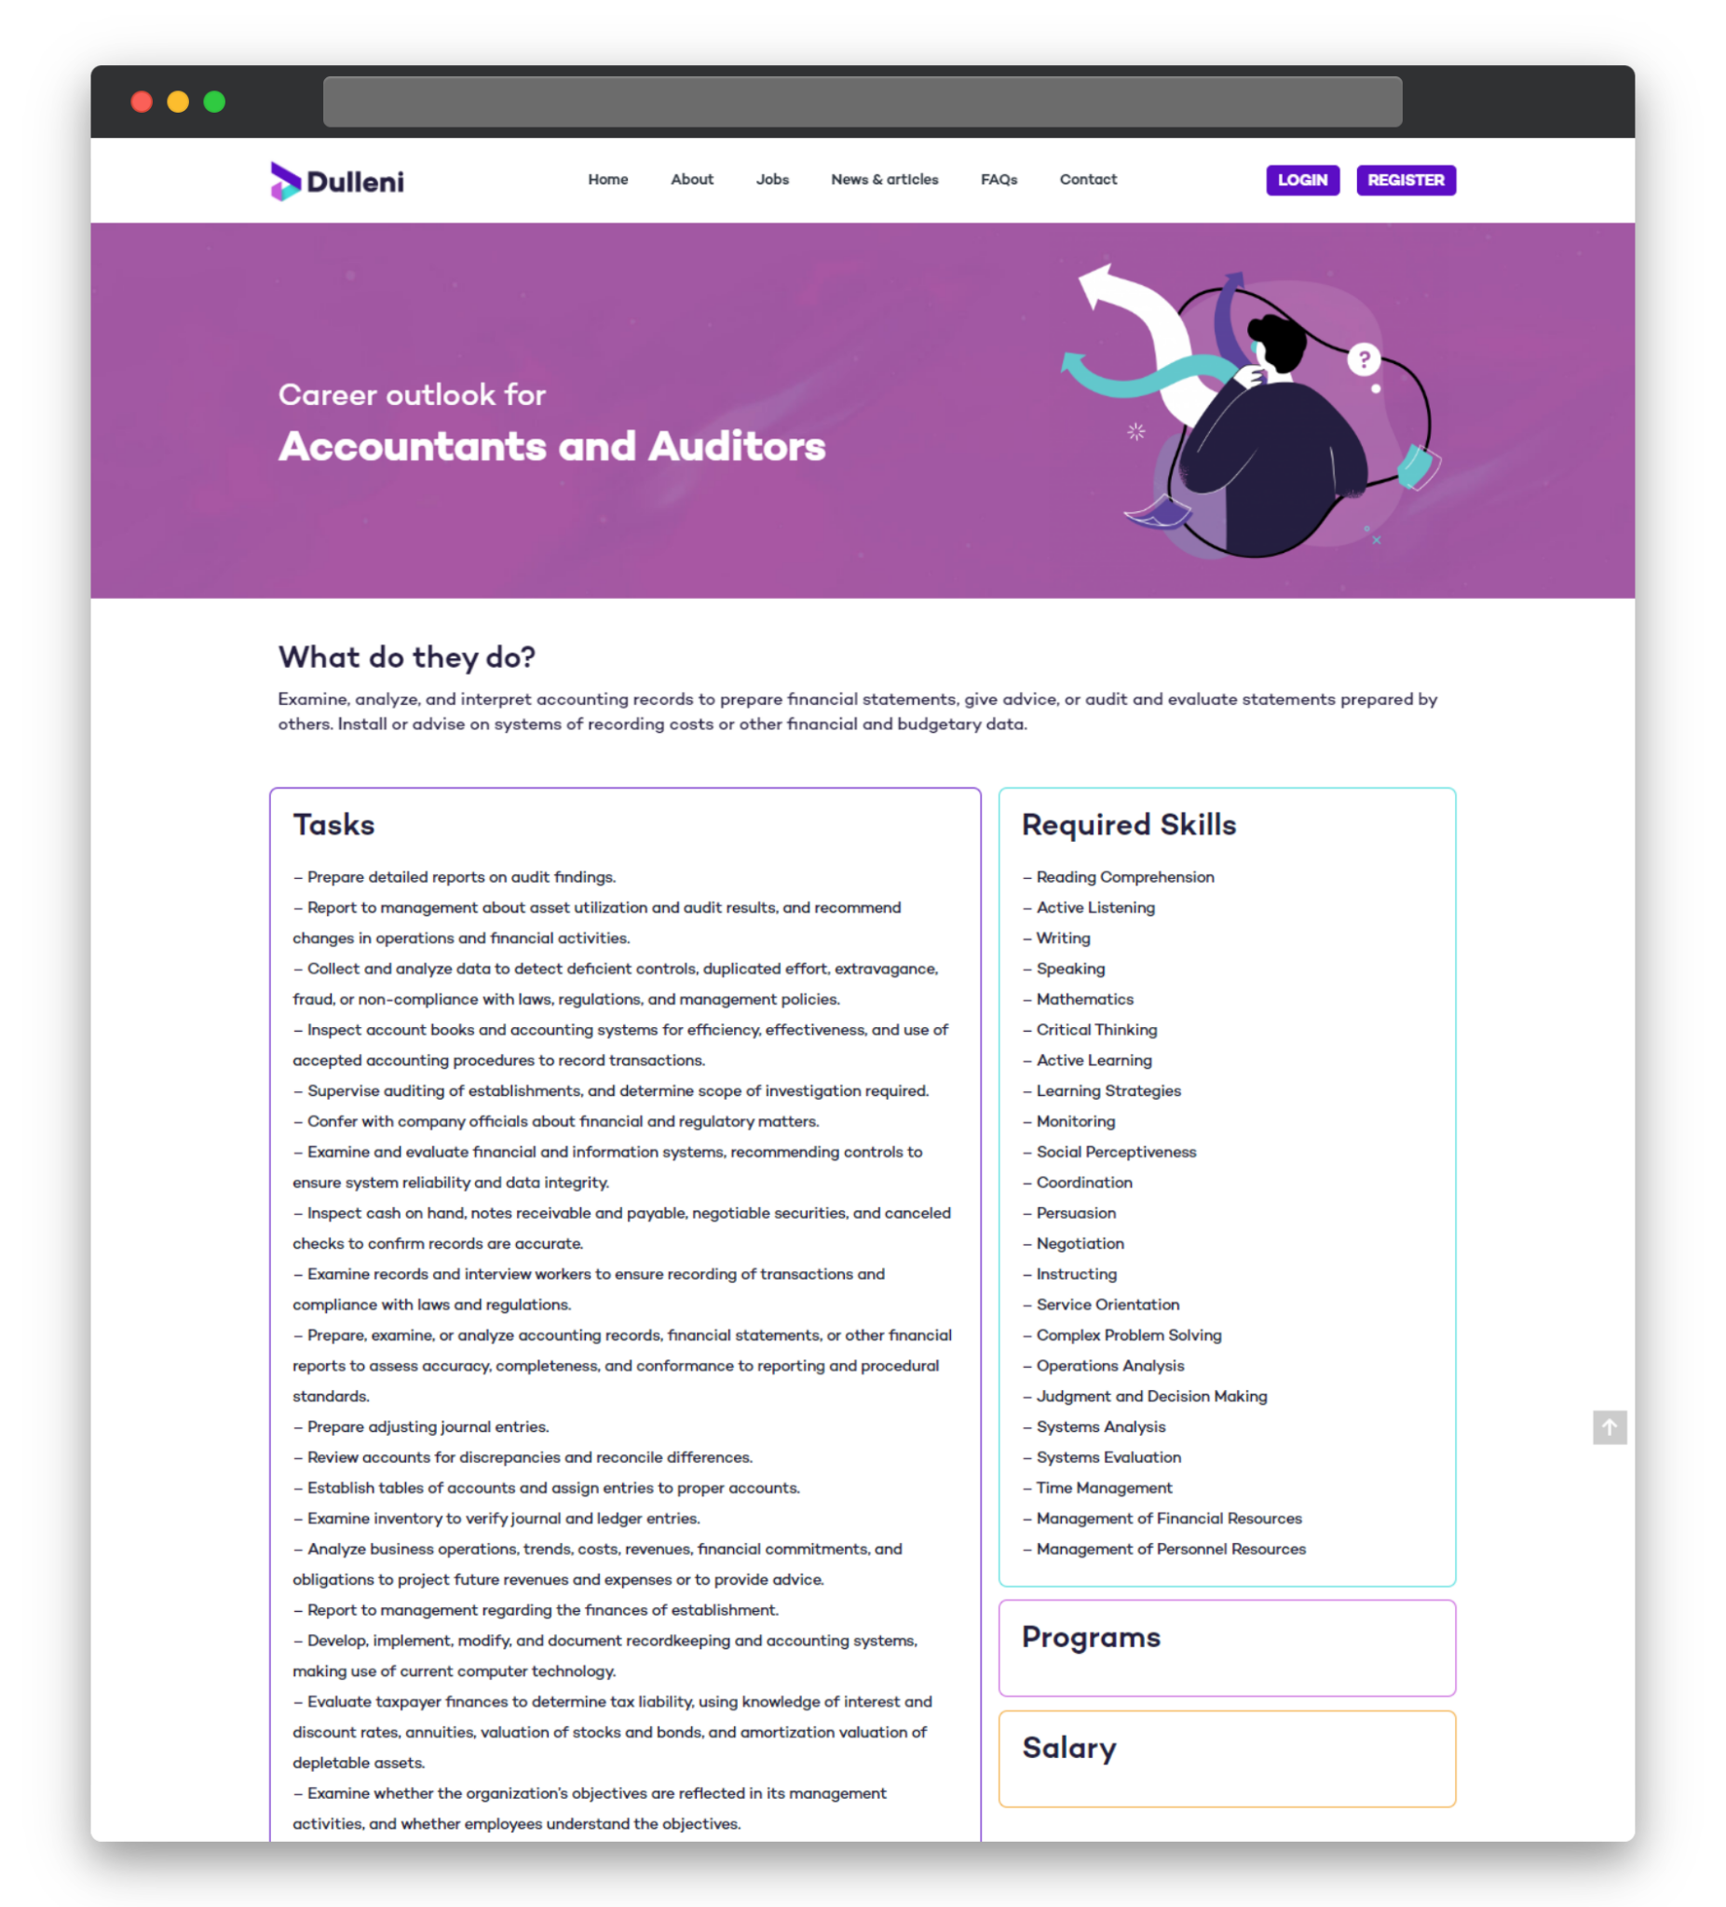

Fig 4.10

#### conclusions - what we discovered along the process

As we progressed through the research phase, the establishment of the framework architecture, and the inception of our modules, we came to a variety of conclusions, some of which resulted in the following challenges, aims, or problems for which we will provide solutions in our future work:

1. concerning the state of the ICT job market in Egypt
   1. The "optimum state" is not reached in the job market (demand and supply states). This is because, unfortunately, a large number of these graduates face many challenges along their way to meeting the requirements of the job market.
   2. The high ambiguity of the job descriptions resulted from recruiters who are posting these job openings and have no technical background, many duplications, ambiguous fields such as salary, self-made job descriptions, and random tasks.
   3. problems with recognizing job vacancies as a labor market indicator, KLIM [30], as employment by occupation, and employment by sector
2. concerning occupational classification
3. There is no Egyptian occupational classification The version presented by the Central Agency for Public Mobilization and Statistics was found to only be an Arabic translation for the ISCO-08 codes
4. The update factor ISCO is updated every twenty years (1968, 1988, 2008)
5. the lack of international comparability of occupational coding systems
6. These developments call for a specification of 4-digit occupational units with a relatively large share in national labor forces, for example, the occupational unit Cashier. There- fore, the EurOccupations database distinguishes the Check-out operator, Ticket-clerk, and cashier and Ticket clerk from the Cashier The database does not hold an occupational title Clerk but has 32 distinct occupational titles for clerks (change the example to ICT professions)

#### 

#### results -the till now reach

As our project is divided into modules, in this chapter we will discuss the implementation to date for each module.

interface: we have implemented the interface using WordPress building the main pages to present the O*net data. This was done as part of the first prototype and is still in progress.

Knowledge Extraction: in this module, we have scraped job posting data from the Wuzzuf and Nakurigulf websites, and collected course data from Coursera.

skill matching: in this module, we have implemented a skill matching algorithm that takes the student skill and matches it with the best fit occupation for the skills and ranks those occupations based on similarity. We have implemented this code to validate the idea, but it needs some enhancement in future work.

Database: Till now, we have used the O*net database to show it on the website MVP, but we have made changes to its structure to fit the WordPress database structure.

#### future work

1. skill extraction from job posting of wuzzuf
2. The use of online data facilitates analysis over time. It can be used for other purposes besides curricula and job posting comparisons.
3. There are also some limitations to this work: We excluded postings written in Arabic, because of our focus on the English language, and the data in this work is multi-dimensional. Despite this limitation, the presented framework is an efficient tool not only for curriculum developers or academics but also for analysts, students, job applicants, and many others. Additionally, it provides insights into the predominant jobs and skills in computing fields.

# 

# References

[1]ministry of planning and economic development, “the annual ecnomic bulletin,” ministry of planning and economic development, 2021. Accessed: Sep. 10, 2022. [Online]. Available: <https://mped.gov.eg/>

[2]R. Assaad, C. Krafft, and D. Salehi-Isfahani, “Does the type of higher education affect labor market outcomes? Evidence from Egypt and Jordan,” *Higher Education*, vol. 75, no. 6, pp. 945–995, Aug. 2017, doi: 10.1007/s10734-017-0179-0.

[3]Information Technology Industry Development Agency, “Information Technology Industry Development Agency,” *Itida.gov.eg*, 2019. <https://itida.gov.eg/English/Pages/Why-Egypt.aspx> (accessed Sep. 17, 2022).

[4]Dr. R. Roushdy, “Author Dr. Rania Roushdy (1),” 2021. Accessed: Dec. 31, 2022. [Online]. Available: <https://www.ilo.org/wcmsp5/groups/public/---africa/---ro-abidjan/---sro-cairo/documents/publication/wcms_856457.pdf>

[5]Ministry of Communications and Information Technology, “Ministry of Communications and Information Technology,” *mcit.gov.eg*. <https://mcit.gov.eg/en/Human_Capacity/MCIT/Basic_Digital_Skills_Development_Programs> (accessed Dec. 31, 2022).

[6]Ministry of Communications and Information Technology, “Ministry of Communications and Information Technology-Beta Version,” *mcit.gov.eg*, 2021. <https://mcit.gov.eg/Upcont/Documents/Reports%20and%20Documents_412022000_ICT%20Sector%20Achievements%20in%202021_EN.pdf> (accessed Sep. 21, 2022).

[7]ACT Inc., “A Better Measure of Skills Gaps UtilizinG ACt Skill Profile And ASSeSSMent dAtA for StrAteGiC Skill reSeArCh SHARE,” 2011. Accessed: Oct. 27, 2021. [Online]. Available: <https://www.act.org/content/dam/act/unsecured/documents/abettermeasure.pdf>

[8]A. Tymon, “The student perspective on employability,” *Studies in Higher Education*, vol. 38, no. 6, pp. 841–856, Aug. 2013, doi: 10.1080/03075079.2011.604408.

[9]K. Tijdens, “The EurOccupations database and its underlying principles First Reporting Period -D01a,” 2006. Accessed: Oct. 19, 2022. [Online]. Available: <https://wageindicator.org/copy_of_documents/Deliverables%20year%201/D01a-EurOccupations-Underlying-principles-Occupations-and-arguments.pdf>

[10]International Labour Organization, “International Labour Organization,” *Ilo.org*, 2019. <https://www.ilo.org/global/lang--en/index.htm>

[11]“| Esco,” *esco.ec.europa.eu*. <https://esco.ec.europa.eu/en/classification/occupation_main#overlayspin> (accessed Dec. 31, 2022).

[12]P. E. Abigail Mcknight, “Skill measurement in official statistics: recent developments in the UK and the rest of Europe,” *Oxford Economic Papers*, vol. 53, no. 3, pp. 508–540, Jul. 2001, doi: 10.1093/oep/53.3.508.

[13]“التصنيف العربي المعياري للمهن,” *منظمة العمل العربية*. <https://alolabor.org/arab-soc/> (accessed Oct. 05, 2022).

[14]CAPMAS, “دليل التصنيف المهنى,” *Capmas.gov.eg*, 2020. <https://www.capmas.gov.eg/Pages/StaticPages.aspx?page_id=5082> (accessed Sep. 24, 2022).

[15]aomisned, “التصنيف السعودي الموحد للمهن,” *الهيئة العامة للإحصاء*, Sep. 17, 2020. <https://www.stats.gov.sa/ar/page/292> (accessed Dec. 31, 2022).

[16]Tanqeeb, “لائحة اكواد الوظائف من مكتب التأمينات الاجتماعية في مصر – وظائف تنقيب,” *Tanqeeb.com*, Jul. 14, 2019. <https://www.tanqeeb.com/career/category/%D9%84%D8%A7%D8%A6%D8%AD%D8%A9-%D8%A7%D9%83%D9%88%D8%A7%D8%AF-%D8%A7%D9%84%D9%88%D8%B8%D8%A7%D8%A6%D9%81-%D9%85%D9%86-%D9%85%D9%83%D8%AA%D8%A8-%D8%A7%D9%84%D8%AA%D8%A3%D9%85%D9%8A%D9%86%D8%A7%D8%AA/> (accessed Dec. 31, 2022).

[17]الهيئة القومية للتأمين الاجتماعي, “الهيئة القومية للتأمين الاجتماعي,” *nosi.gov.eg*, 2020. <https://nosi.gov.eg/ar/Pages/HomePage/Home.aspx> (accessed Sep. 27, 2022).

[18]BasharSoft LLC., “Jobs in Egypt - WUZZUF | وظف.كوم,” *WUZZUF*. <https://wuzzuf.net/jobs/egypt>

[19]infoedge, “Naukrigulf,” *www.naukrigulf.com*. <https://www.naukrigulf.com/>

[20]HolonIQ, “Education in 2030 - The $10 Trillion dollar question,” *HolonIQ*. <https://www.holoniq.com/2030>

[21]National Center for O*NET Development., “My Next Move,” *Mynextmove.org*, 2019. <https://www.mynextmove.org/>

[22]D. D. - KMi, “Qualichain,” *Qualichain*, Feb. 08, 2019. <https://qualichain-project.eu/deliverables/> (accessed Dec. 31, 2022).

[23]SFIA Foundation 2003-2021, “The global skills and competency framework for a digital world,” *SFIA*, 2021. <https://sfia-online.org/en>

[24]M. Burrows, “SFIA Mapping to Saudi Classification of Professions,” 2021. Accessed: Oct. 16, 2022. [Online]. Available: <https://sfia-online.org/en/assets/documents/mapping-documents/mcit_sfia_mappingforsaudiclassificationofprofessions_march2021.pdf>

[25]Tx Management Systems Pty Ltd 2019, “Digital Skills Management Maturity Registration,” *SkillsTX | Passion for Potential*, 2019. <https://skillstx.com/dsm-maturity-registration/> (accessed Oct. 21, 2022).

[26]N. N. S. Ismail and H. A. Ali, “IMPLEMENTING RAPID APPLICATION DEVELOPMENT (RAD) METHODOLOGY IN DEVELOPING ONLINE LABORATORY AND ROOM BOOKING SYSTEM (eLABAS),” 2018. Accessed: Nov. 06, 2022. [Online]. Available: <https://www.researchgate.net/publication/324538125_IMPLEMENTING_RAPID_APPLICATION_DEVELOPMENT_RAD_METHODOLOGY_IN_DEVELOPING_ONLINE_LABORATORY_AND_ROOM_BOOKING_SYSTEM_eLABAS>

[27]A. Ashari, I. Paryudi, and A. Min, “Performance Comparison between Naïve Bayes, Decision Tree and k-Nearest Neighbor in Searching Alternative Design in an Energy Simulation Tool,” *International Journal of Advanced Computer Science and Applications*, vol. 4, no. 11, 2013, doi: 10.14569/ijacsa.2013.041105.

[28]C. Slamet, R. Andrian, D. S. Maylawati, Suhendar, W. Darmalaksana, and M. A. Ramdhani, “Web Scraping and Naïve Bayes Classification for Job Search Engine,” *IOP Conference Series: Materials Science and Engineering*, vol. 288, p. 012038, Jan. 2018, doi: 10.1088/1757-899x/288/1/012038.

[29]T. S.L., I. W.H., and T. Albert, “Is Naïve Bayes a Good Classifier for Document Classification?,” *International Journal of Software Engineering and its Applications*, vol. 5, 2011, Accessed: Nov. 09, 2022. [Online]. Available: <https://www.researchgate.net/publication/266463703_Is_Naive_Bayes_a_Good_Classifier_for_Document_Classification>

[30]International Labour Office, *Key indicators of the labour market*. Geneva: Ilo, 2016.

[31]A. Soni and V. Ranga, “API Features Individualizing of Web Services: REST and SOAP,” *International Journal of Innovative Technology and Exploring Engineering*, vol. 8, no. 9S, pp. 664–671, Aug. 2019, doi: 10.35940/ijitee.i1107.0789s19.

[32]R. Choirudin and A. Adil, “Implementasi Rest Api Web Service dalam Membangun Aplikasi Multiplatform untuk Usaha Jasa,” *MATRIK : Jurnal Manajemen, Teknik Informatika dan Rekayasa Komputer*, vol. 18, no. 2, pp. 284–293, May 2019, doi: 10.30812/matrik.v18i2.407.

[33]vijay surwase, “REST API Modeling Languages - A Developer’s Perspective,” *International Journal of Science Technology & Engineering*, vol. 2, no. 10, 2016.

# List of acronyms and symbols (abbreviations)

| ISCO | International Standard Classification of Occupations |
| --- | --- |
| SOC | Security Operation Center |
| NOC | National Occupations Classification |
| ESCO | European Standard Classification of Occupations |
| ILO | International Labor Organization |
| ICT | Information Communication Technology |